

MASTER IN DATA SCIENCE FOR MANAGEMENT

SUBJECT : ANALYSIS OF QUESTIONNAIRE

PROF. : G.COMMIS

**ETNA WINERY SURVEY**



Students:

**GIANLUIGI MAZZAGLIA**

**ANAHITA ESFANDIARYFARD**

**BIAGIO INCARDONA**

**THAMIRES DE SOUZA OLIVEIRA**

Academic year 2021-2022

**Table of Contents**

INTRODUCTION 3

1. Questionnaire Structure 3

1.1. Dataset 6

2. Univariate Analysis 6

As we can see almost 75.30% of our repondants are from Sicily 24

3. Missing values Handling 25

3.1. Handling Missing Value 26

3.1.1. Numeric Variables 26

3.1.2. Categorical Variables 26

4. Multivariate Analysis 26

4.1. Analysis of Correspondence 26

4.2. Latent Class Analysis(LCA) 26

4.3. Principal Component Analysis(PCA) 26

4.4. Factor Analysis 31

4.5. IRT- Item Response Theory 31

4.5.1 Dataset level IRT 32

4.5.2 IRT on topics 40

Conclusion 57

Appendix: questionnaire improvement 57

## INTRODUCTION

The present study, with reference to the wine, was carried out between December and January 2020/21. The purpose of the survey was to discover winery market trends and customer preferences, focusing on Etna wines. All data have been collected anonymously in line with the privacy policy. Our project was done using the statistical software SAS, in particular after a firstly description of the Questionnaire Structure we did the Univariate Analysis in order to understand the distribution of the answer. Then we handled the missing values and we performed Multivariate Analysis, in particular we focus on Item Response Theory, Factor Analysis and Latent Class Analysis.

The Questionnaire was organized in four sections, the first of which was dedicated to the wine preferences, expertise and consumers’experience ( drinking frequency, type of drinks / wine, winery experience). The second part is referred to the buying experience ( buying frequency, consumed quantities, consumption time, factors that influence the purchasing moment). The third part of the questionnaire allowed us to collect information about the knowledge an consumption of Etna DOC (where the respondents will give an answer just in case they heard about Etna wine). The fourth section allowed us to obtain information on the socio-economic characteristics of the respondent (age, gender, level of education, occupation).

# Questionnaire Structure

The Questionnaire is structured in 23 questions, that contains in total 42 elements.

*Section 1: Wine preferences, expertise and experience*

Question 1 : How much do you like the following drinks?

The questions contains 4 items and asks the respondent how much do they like drinks like wine, beer, soft drinks and cocktails. Every item is placed on a semantic scale from 1 (not at all) to 4 (a lot). This question can be useful to understand the drinking preference of the respondent.

Question 2: How much do you like the following kinds of wine?

The question contains 5 items from 1 to 4 adding the possibility to answer “Never tasted”. As before every item is placed on a semantic scale from 1 (not at all) to 4 (a lot). This question allow us to understand which kind of wine the respondent prefers within red, white, rose’, sparkling and sweet.

Question 3 : Have you ever tried a wine tasting experience?

This question asks to the respondent if he never tried a wine tasting experience, it’a a categorical variable with binary choice between yes or not. Answer this question can help us with the analysis in order to categoryze the typology of respondent, likely a person who is interested in things like this can have an high at least curiosity to improve his knowledge of wine.

Question 4: Have you ever visited a winery?

Also this question it’s a categorical variable with binary choice between yes or not. Like the previous question, it can be useful to understand if the respondent is used to going in a winery.

Question 5: Have you ever attended an in-depth wine course?

This question asks to the respondent if he never attended a wine course, it’s a categorical variable with binary choice yes or not. This allow us to better understand the respondent in terms of technical expertise.

Question 6: Which is your level of knowledge around wines?

It’s a closed item that asks about the level of knowledge around wines of the respondent, in particular it is an ordinal scale ordered from “None” (no knowledge) to “High” (professional knowledge level). This answer can also useful to understand if matches with the previous questions, a respondent who has followed a depth course it’s supposed to have an high level of knowledge around wines.

Section 2: Wine buying Experience

Question 7: How often do you buy wine on average in a month?

The question asks the respondent how often he buy wine on average in a month, it’s an ordinal variable and only one answer is allowed. The utility of this question can be to better understand if the respondent is a frequently user of wine.

Question 8: How many bottles of wine do you buy on average per month?

The question can be similar to the previous one, It’s an ordinal variable and only one answer is allowed. The difference to the previous question is to understand the quantity of bottles that the respondent buy monthly (he can choose in a range from 1-3 bottles, 4-6, to more than 12 bottles) and it can be useful to highlight if he is a consumer during meals or maybe he just want to keep some bottles to share with the others.

Question 9: How often do you buy wine in the following store?

This question contains 3 items and each of them is placed on a semantic scale from 1 (never) to 4 (every time) in order to understand if the respondent used to buy wine in a supermarket, in a winery or online, so we can better understand the typology of consumer.

Question 10: How relevant are the following features when you buy a wine?

This question contains 8 items and it’s asked to the respondent to answer a list of features that he consider important during the buying transaction. Every item is placed on a semantic scale from 1 (not at all relevant) to 4 (extremely relevant) and we find items like grape origin, grape variety, budget friendly, brand awarness, vintage, label detailed, attractive packaging, eventual promotions. This question could be extremely important to understand which of the following features can move on our respondent when he buy a wine and so we can realize the kind of person we are referring to.

Question 10: How much do you spend on a bottle of wine on average?

It’s a closed item that can be placed in an ordinal scale and ask to the respondent how much he is spend on average for a bottle of wine. The answer can be just one and this information can be useful to understand if an higher quality of wine is important for the respondent and how he can afford to spend on it.

Question 11: During the pandemic, did the frequency with which you buy wine change?

The question contains 1 item and asks to the respondent if during the pandemic the frequency with which you buy wine is changed. Every item is placed on a semantic scale with 5 points and a middle point 0. This question can be useful to understand if the pandemic period has changed the habits of the consumer.

Question 12: For what reason have you bought wine in the last 3 months?

The question asks to the respondent the reason why he bought wine in the last 3 months. The question is a multi select Multiple choice question and allows to choice more than one option (within Home consumption, to buy a gift, for a special event, to try a new wine) and also allow using an opened answer to insert “Other” if the option doesn’t belong to the alternative. The utility of this question allow us to define a reason why the respondent used to buy wine.

Section 3: Etna DOC wine

Question 13: Have you ever heard about Etna DOC wine before?

This question is mandatory and according to the answer that the respondent will give, the next question will be different. In particular the question asks if the respondent has never heard about Etna DOC. It is a categorical variable with binary choice between yes or not. This question can be useful to understand if the respondent knows the Etna DOC or not. This item performs a branching and who answers no is skipped to the final section.

Question 14: Have you ever bought Etna wine?

It is a closed item and it asks the respondent if he never bought Etna wine. It’s a categorical variable with 3 choice (Yes, No, I don’t know) and it is useful to understand if the respondent has never testef Etna wine.

Question 15: How much do you like Etna wines more than other wines?

This question asks to the respondent how much he likes Etna wine more than other wines. Every item is placed on a semantic scale from 1 (not at all) to 4 (a lot). This question allow us to understand if the respondent appreciates the taste of Etna wine.

Question 16: How much do you agree with the following statements about Etna wine?

This question contains 4 closed items and asks to the respondent how much he agrees with certain statements. Every item is placed on a Likert scale with 4 modes from 1 (not at all in agreement) to 4 (completely in agreement). The utility of this question is to understand respondents’ opinion about Etna wine.

Question 17: How likely are you to recommend Etna wine to your family and friends?

This question asks to the respondent how likely they would recommend Etna wine to family and friends. It is on a Likert scale with 4 modes from 1 (not likely at all) to 4 (extremely likely). This question is useful to understand if respondents consider Etna wine as one of the top quality wine and they also provide to recommend it to closers.

Section 4: Socio – demographic data

Question 18: Please enter your gender.

This is a closed item and the question asks to the respondent his gender. It is a categorical variable with 3 choices (man, woman, prefer not to say).

Question 19: Please enter your age:

This question is an open item on an interval scale and the answer is required. It asks the respondent his/her age and give us a discrete variable in a set that is finite as a lower bound, so the respondent must have an age not less than 18, while the upper bound is infinite.

Question 20: Please enter your level of education.

This question allow us to understand the level of education of the respondent. We have here an ordinal scale (from primary and Medium school to University degree). This question can be useful to understand if could be a correlation between people who have an higher level of education and the knowledge of Etna wine and if in general the choices during shopping time can be different.

Question 21: Where are you from?

This question is a closed item. It asks the respondent the place where he/she comes from. It is a categorical variable with multiple modes. The respondent can be Sicilian, Italian, from an EU country or not EU.

Question 22: What is your occupation?

It is a closed item and asks to the respondent what is her/his occupation. It is a categorical variable with multiple modes. If the occupation is not in the list the respondent can also add his own job applying an open item in the space next to the voice “Other”.

## Dataset

Since we had to form in two languages Italian and English in order to target majority of people(Italians and non Italians), then we initialy had two dataset in both languages. So we started by translating italian dataset. The next step is to convert variables from character to numeric. and then we merged the two dataset together to create a unique dataset.

In the next step we transformed categorical variables “Etna buying”, “wine knowledge”, “bottle budget”, “buying experience” and “wine bottles” to numerical values.

For question related to reason of buying wine we decided to transform answers into columns so we added four columns to dataset: party, gift, home, taste and we fill the data with 0 and 1 based on the respondents answer. We did this so we will be able to analize this part better.

Also we classified age into groups for later analyse.

# Univariate Analysis

Section 1: Wine preferences, expertise and experience

Question 1 : How much do you like the following drinks?

This question is a scale of preference to each type of drink, because of that we divided the graphs of barplot and table of frequency in each kind of drink to have a better view of the results, we will analyse the 247 responses.



The third drink to be analysed is cocktail, where we can check through the graph that almost the same amount of people chose both level 2, 3 or 4 preference in this type of drink, and the minority chose option 1.

The first analysis is over beer preference, where 34% of the people declared that they like beer in a level 4 (a lot) and only 17% declared that the preference of beer is “not at all”. The pattern of the graph is the decrease of responses in the order from 4 to 1 in the level of preference.

The second drink to be analysed is soft drinks preferences, like coca-cola, soda,etc. In this case the major part of the people that chose level 2 for their preference for this type of drink, whichis considered a low level. Just over 26% declared that they like this kind of beverage a lot.



The fourth analysis is over wine preference, where 46.56% of the people declared that they like wine in a level 4 (a lot) and only 8.10% declared that the preference of wine is “not at all”. The pattern of the graph is the decrease of responses in the order from 4 to 1 in the level of preference.

Question 2: How much do you like the following kinds of wine?

This question is another scale of preference with 247 answers. We will show the results by barplot and table of frequency to each option of wine and analyse it separately:

The first wine to be analysed is whine wine preference, in this case its possible to see that the majority chose the level 3 of preference in this kind of drink and almost 70% of all observations are concentrated on levels 3 and 4.



In red wine observation 72% of people are accumulated on levels 1 and 2 of preference.



The other wine preference to be analysed is rose wine which has its majority at level 2 of preference and only 14,2% at level for of preference.



We can see that on sparkling wine preferences, we have less people on level 4 and we have a cumulative percent of 80,16% on levels 1, 2 and 3.



At the analysis of sweet wine, we can see that we have its minority on 4 level and the majority of people, almost 60%, are concentrated on the first 2 levels.

Question 3 : Have you ever tried a wine tasting experience?

This is a simple categorical question with binary choice, where 0 means no and 1 means yes. In this case we can check that more than the half (57,1%) never tried a wine taste experience.



Question 4: Have you ever visited a winery?

Like the previous one is also a binary choice with yes and no options, in this case we can check that 60,3% of people already visited a winery.



Question 5: Have you ever attended an in-depth wine course?

Another binary question, where we can check that 82,2% never had any depth wine course.



Question 6: Which is your level of knowledge around wines?

It’s a closed question where we can check that 87,85% of people are acumulated on levels 1,2 and 3 of knowledge around wine, and most of it are concentratedon level 2.





Section 2: Wine buying Experience

Question 7: How often do you buy wine on average in a month?

As we can check, most of the people (64%) declared to buy wine once a month and 86% of the observations were accumulated until 2 times a month.



Question 8: How many bottles of wine do you buy on average per month?

As we can check 42,1% of people declared to buy 2 bottles of wine per month and 72,06% of the observations are accumulated until only 2 bottles per month.

Question 9: How often do you buy wine in the following store?

This question is another scale of preference from 1 (never) to 4 (every time) with 247 answers. We will show the results by barplot and table of frequency to each option of store and analyse it separately:



In supermarket observation almost 75% of people buy wine on supermarket o levels 3 and 4, that are the highest levels of frequency of buying.



Differently from the previous one, people who declared to buy wine in wine shops are acumulated almost 76% at first 2 levels, that are the lowest ones, and 46,6% buy on wine shops on level 2 of frequency.



Most of the people, exactly 85,4%, never buy wine at online shop and only 3 declared to buy by that method every time.

*Question 10: How relevant are the following features when you buy a wine?*

This question is another scale of preference from 1 (not all relevant) to 4 (extremely relevant) with 247 answers. We will show the results by bar plot and table of frequency to each option of features and analyse it separately:



For most of the people the grape origin has the relevance of level 3 and the comulative with level 4 is for 74,9% what means is a really relevant feature.



For most of the people the grape variety has the relevance of level 3 and the comulative with level 4 is for 70,5% what means is a really relevant feature.





The feature of being budget friendly has the relevance of 3 for the most of people and the cumulative with level 4 is of 82,1% what means is also a relevant feature.



Like the other ones most of the people consider the brand awarness of level 3, and the relevance of level 2 and 4 are pretty much the same.



Unlike the other features, vintage has the relevance of 2 for more than half of the people what shows that is one of the less relevant features so far.

The feature of having detailed label has the relevance of 3 for the most of people and the cumulative with level 2 is of 68%.



More than half of people, exactly 52,2%, declared that packaging has a relevance of 2 for them.



Almost half of people, exactly 48,2%, declared that packaging has a relevance of 2 for them.



*Question 11: How much do you spend on a bottle of wine on average?*

As we can check, more than half of the people, exactly 61.54% spend aound 5 to 15 euro, which if we look at the ocupation of our respondents we see majority are students which it makes sense.And only 0.40% of our sample buy wines costs more than 50 euro.

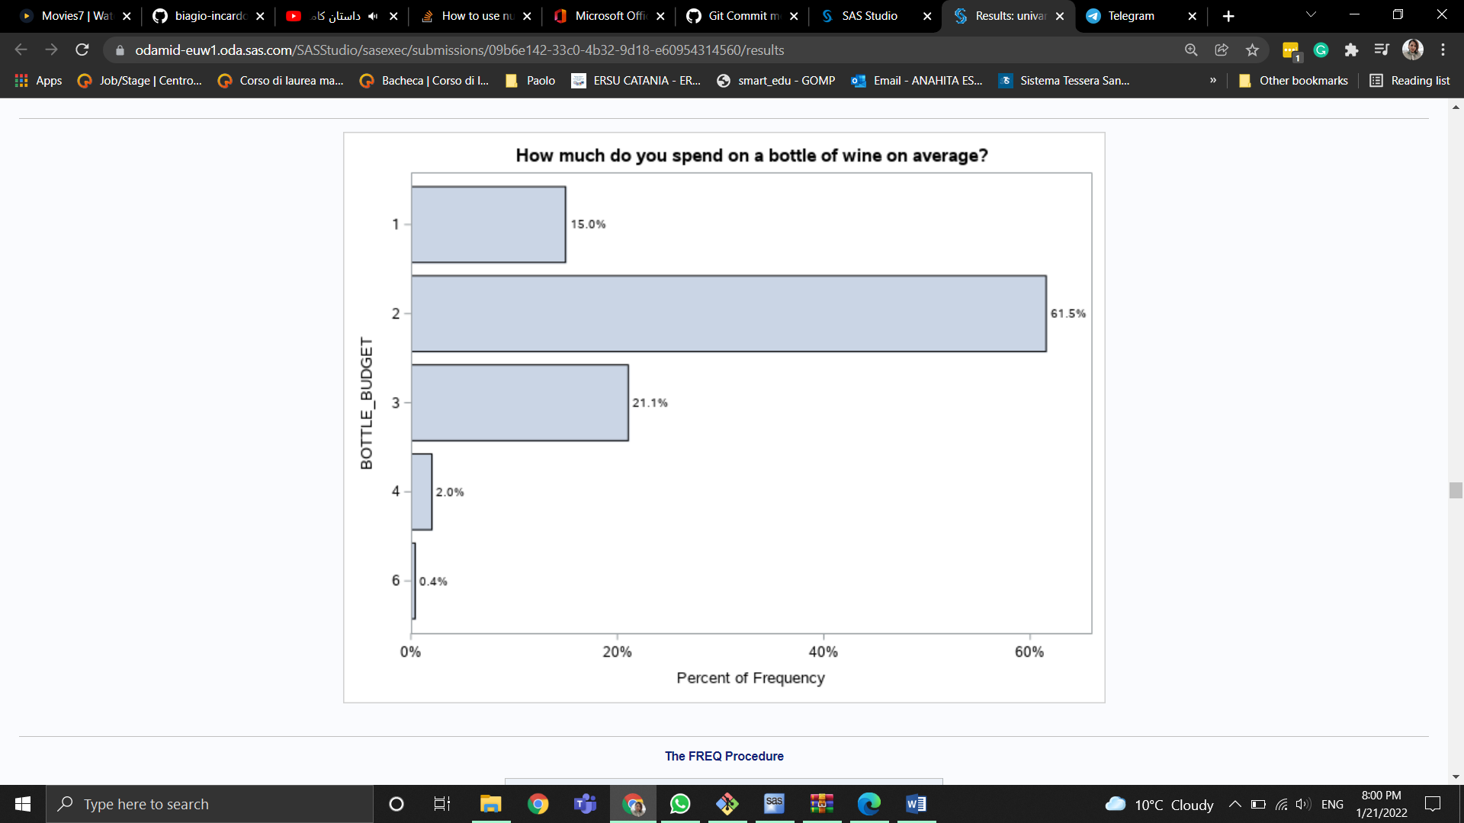

*Question 12: During the pandemic, did the frequency with which you buy wine change?*

As we can check, more than half of the people, exactly 59,5%, during the pandemic, didn't change any habits related to buying wine. Instead, 24.3% increased the number of wine purchases and 16.2% decreased the amount of wines purchased.



*Question 13: For what reason have you bought wine in the last 3 months?*

As we can check, almost half of the people, exactly 52.88%, bouth the wine for home consuming. Instead, only 8.23% bouth wine just for test it.



*Section 3: Etna DOC wine*

*Question 14: Have you ever heard about Etna DOC wine before?*



As we can observe 55,47% of people had heard about Etna Wine before.

*Question 15: Have you ever bought Etna wine?*

As we can observe more people declared that they never bought etna wine (48,6%) and we still have a amount of people (10,1%) that don’t know if they bought Etna Wine or not.



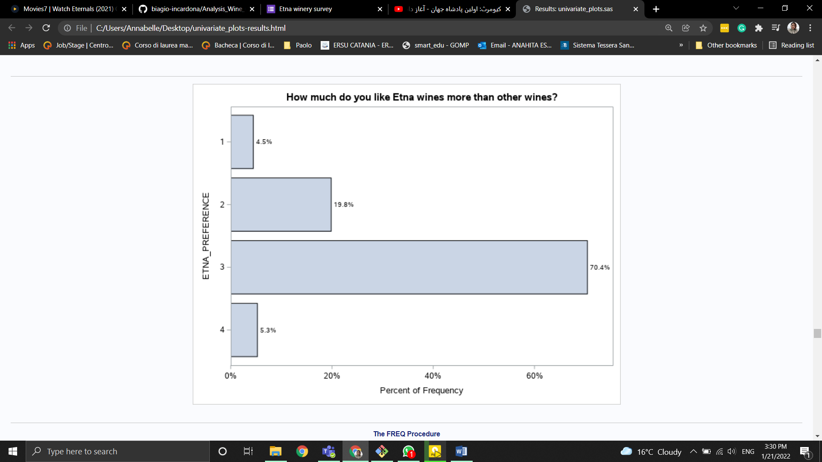*Question 16: How much do you like Etna wines more than other wines?*

As we can observe more people (70%) declared that they prefer etna wine 3 out of 4 scale and almost 20% of peaople prefer it 2 out of 4 we can say majority of people has middle prefrance about this wine.



*Question 17: How much do you agree with the following statements about Etna wine?*

This question is another scale of preference from 1 (not all relevant) to 4 (extremely relevant) with 247 answers. We will show the results by bar plot and table of frequency to each option of features and analyse it separately:

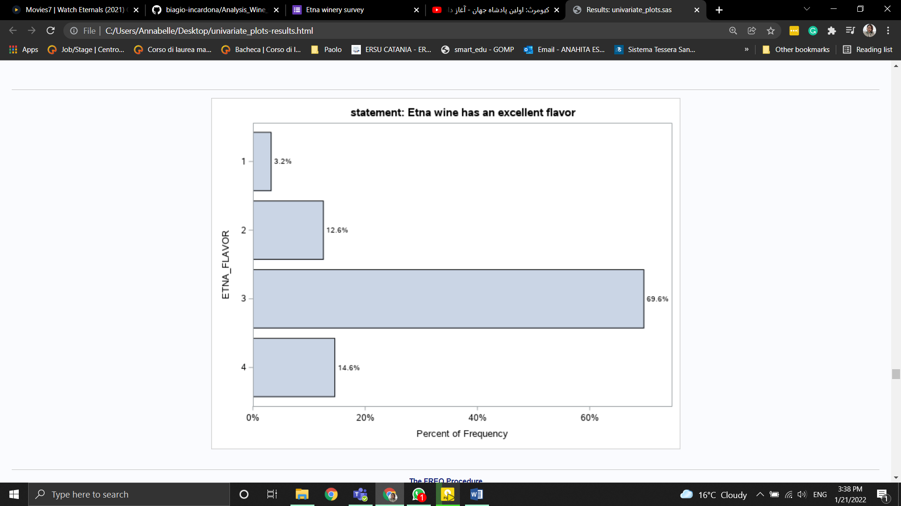

As we can see more than half of people, exactly 69.64%, declared that etna flavor has a relevance of 3 for them.

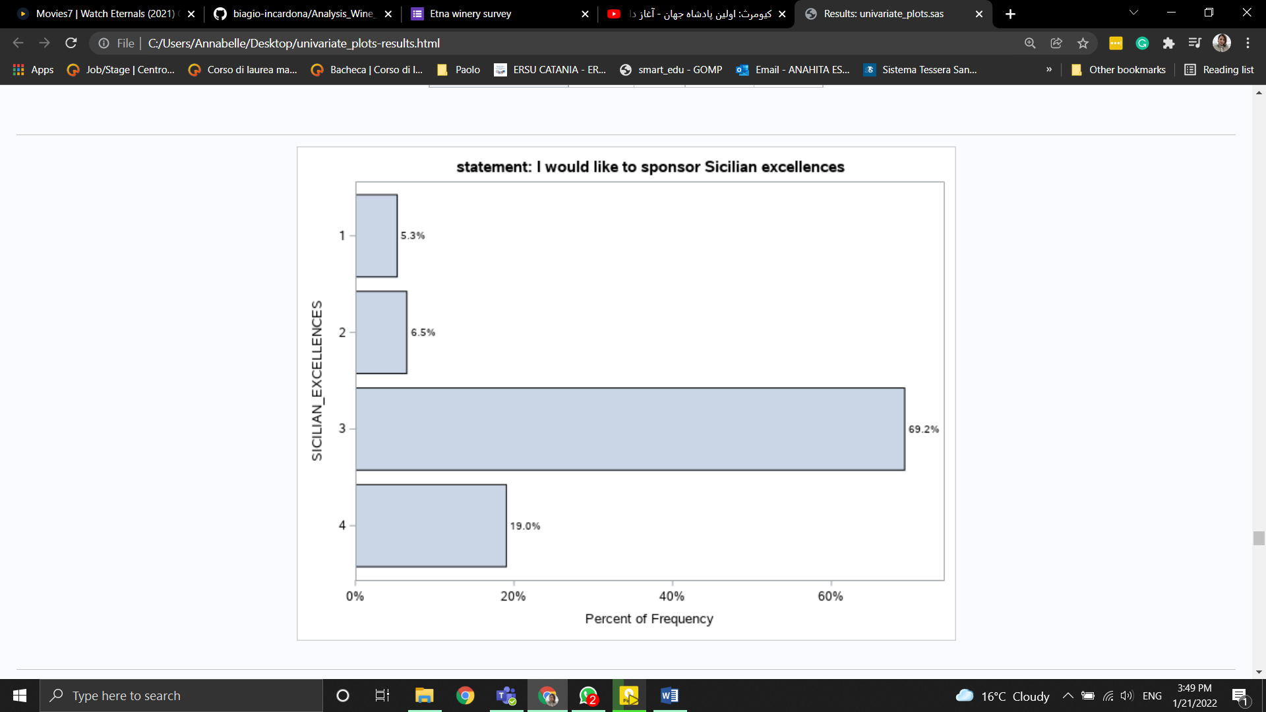

As we can see more than half of people, exactly 69.23%, declared that sicilian excelences has a relevance of 3 for them.

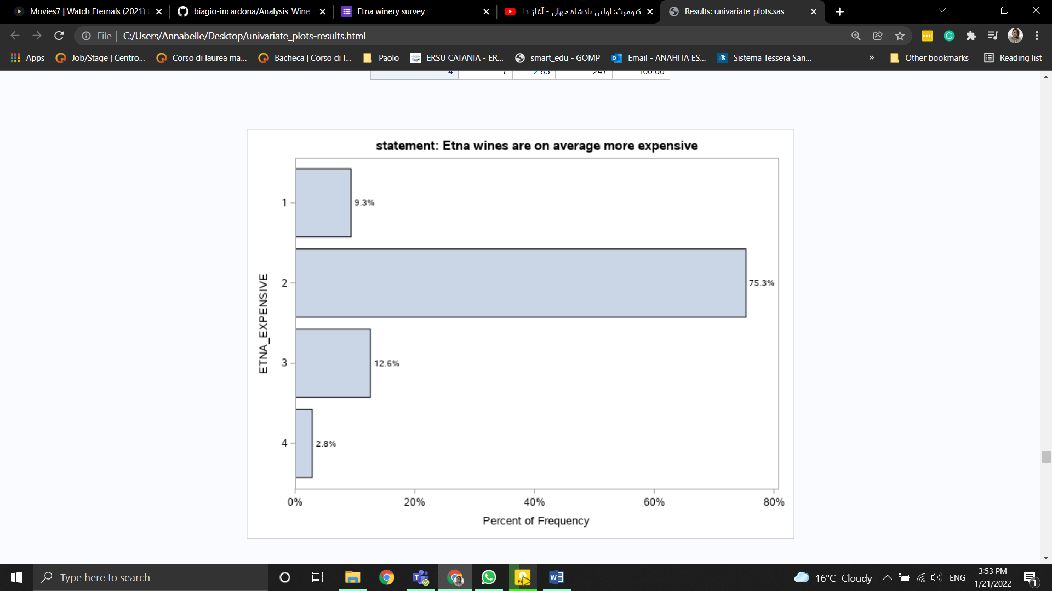

As we can see more than half of people, exactly 75.30%, declared that etna expensive has a relevance of 2 for them. So most peaople don’t consider etna wine as an expensive wine.

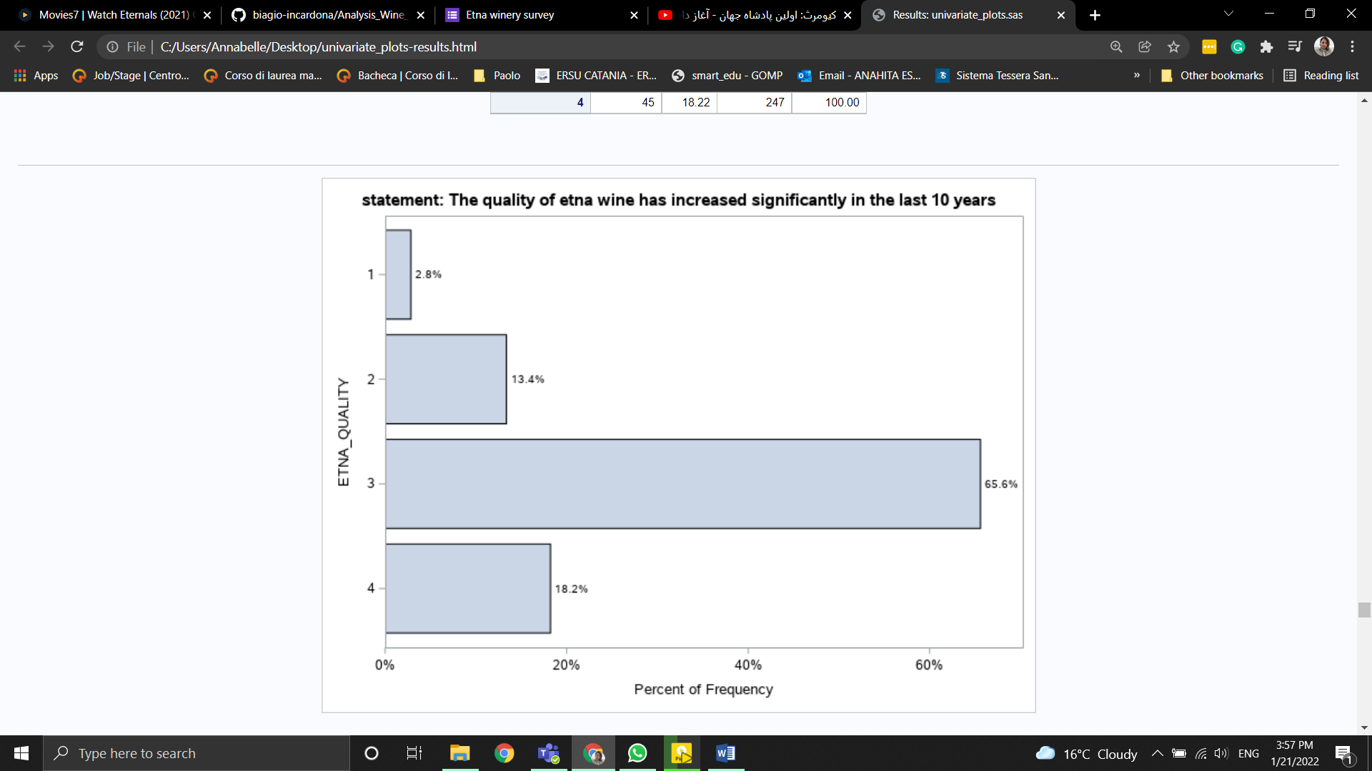

As we can see more than half of people, exactly 65.59%, declared that etna quality has a relevance of 3 for them. So most peaople consider etna wine as a quality wine.

*Question 18: How likely are you to recommend Etna wine to your family and friends?*

This question is scale of peaople recommendation for etna wine from 1 (not all relevant) to 4 (extremely relevant) with 247 answers. We will show the results by bar plot and table of frequency:

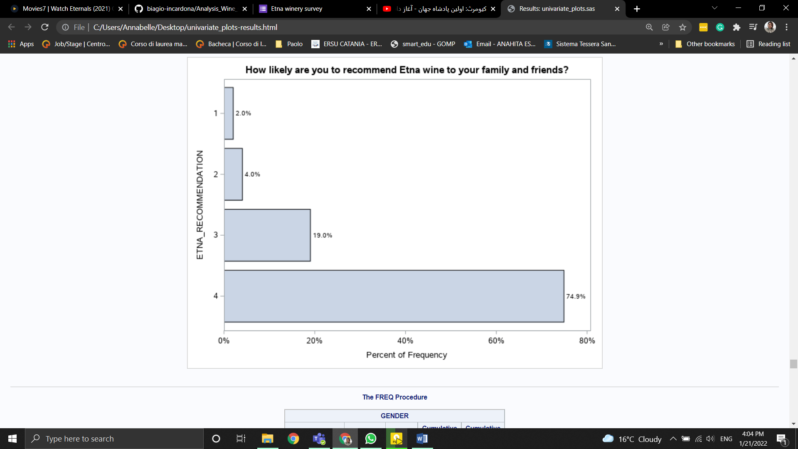

As we can see more than half of people, exactly 74.90%, declared that strongly recommend etna wine to the other peaople.

*Question 19: Please enter you gender*

This question to understand the gender of our respondents, we will show the results by bar plot and table of frequency:

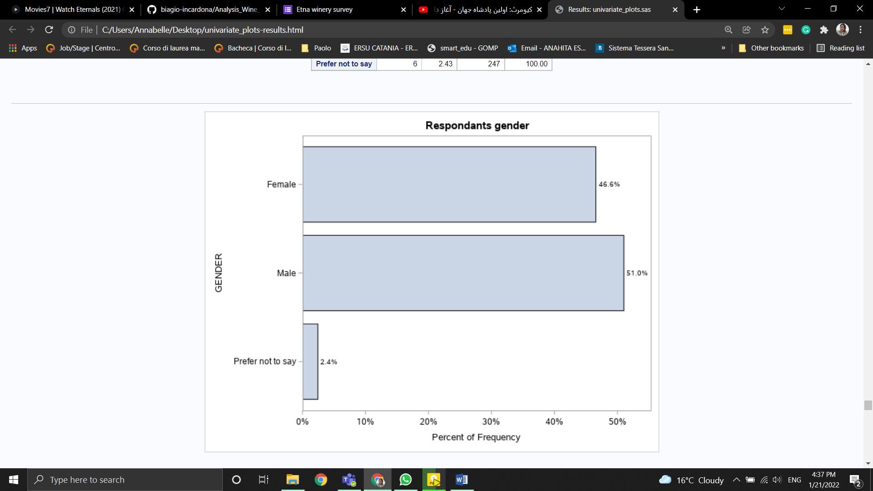

As we can see more than half of respondents, exactly 51.01%, are male.

*Question 20: Please enter your age*

This question to understand the age of our respondents, we will show the results by bar plot and table of frequency:



As we can see almost 32% of our repondants are between 31-50 and after that 29.15% are between 24-30.

*Question 21: Please enter your level of education*

This question to understand the level of education of our respondents, we will show the results by bar plot and table of frequency



As we can see almost 70.85% of our repondants has university degree.

*Question 22: Where are you from?*

This question to understand the location of our respondents, we will show the results by bar plot and table of frequency:



# As we can see almost 75.30% of our repondants are from Sicily

Question 23: What is your occupation?

This question is for understand the type of job our repondant has with 6 options and “other” option for people to write if their ocupation is not listed with 247 answers. We will show the answers by barplot and table of frequency and analyse it

:

 

Most of the people who participated in our research are students with variaty of 37.25 percent and then employee with 35.22 percent.

# Missing values Handling

As we observe from the univariate analysis the dataset contains missing values due to two reasons. One is due to branching of “buying experience” question and hearing about “etna doc” wine question.and Second due to choose “Never tested” in wine prefrence.The following table shows the percentage of missing values:

**Percentage of missing values for numeric variables**

| **Obs** | **_NAME_** | **_LABEL_** | **nvalues** | **nmiss** |
| --- | --- | --- | --- | --- |
| **1** | WHITE_WINE | WHITE_WINE | 199 | 0.5 |
| **2** | ROSE_WINE | ROSE_WINE | 195 | 2.5 |
| **3** | RED_WINE | RED_WINE | 199 | 0.5 |
| **4** | SPARKLING_WINE | SPARKLING_WINE | 198 | 1.0 |
| **5** | SWEET_WINE | SWEET_WINE | 193 | 3.5 |
| **6** | SUPERMARKET | SUPERMARKET | 160 | 20.0 |
| **7** | WINE_SHOP | WINE_SHOP | 160 | 20.0 |
| **8** | ONLINE_SHOP | ONLINE_SHOP | 160 | 20.0 |
| **9** | GRAPE_ORIGIN | GRAPE_ORIGIN | 160 | 20.0 |
| **10** | GRAPE_VARIETY | GRAPE_VARIETY | 160 | 20.0 |
| **11** | BUDGET_FRIENDLY | BUDGET_FRIENDLY | 160 | 20.0 |
| **12** | BRAND_AWARNESS | BRAND_AWARNESS | 160 | 20.0 |
| **13** | VINTAGE | VINTAGE | 160 | 20.0 |
| **14** | LABEL_INFO | LABEL_INFO | 160 | 20.0 |
| **15** | PACKAGING | PACKAGING | 160 | 20.0 |
| **16** | PROMOTION | PROMOTION | 160 | 20.0 |
| **17** | BUYING_FREQUENCY | BUYING_FREQUENCY | 160 | 20.0 |
| **18** | ETNA_PREFERENCE | ETNA_PREFERENCE | 129 | 35.5 |
| **19** | ETNA_FLAVOR | ETNA_FLAVOR | 129 | 35.5 |
| **20** | SICILIAN_EXCELLENCES | SICILIAN_EXCELLENCES | 129 | 35.5 |
| **21** | ETNA_EXPENSIVE | ETNA_EXPENSIVE | 129 | 35.5 |
| **22** | ETNA_QUALITY | ETNA_QUALITY | 129 | 35.5 |
| **23** | ETNA_RECOMMENDATION | ETNA_RECOMMENDATION | 129 | 35.5 |

## Handling Missing Value

### **Numeric Variables**

For handling missing value of numeric variables, Median is replaced with missing items.

### **Categorical Variables**

For handling missing value of categorical variable Mode is replaced with missing items.

# Multivariate Analysis

## Analysis of Correspondence

## Latent Class Analysis(LCA)

## Principal Component Analysis(PCA)

The Principal Component Analysis, helps us to understand if it is possible to reduce the number of variables. First we find the corrolation between numeric variables:

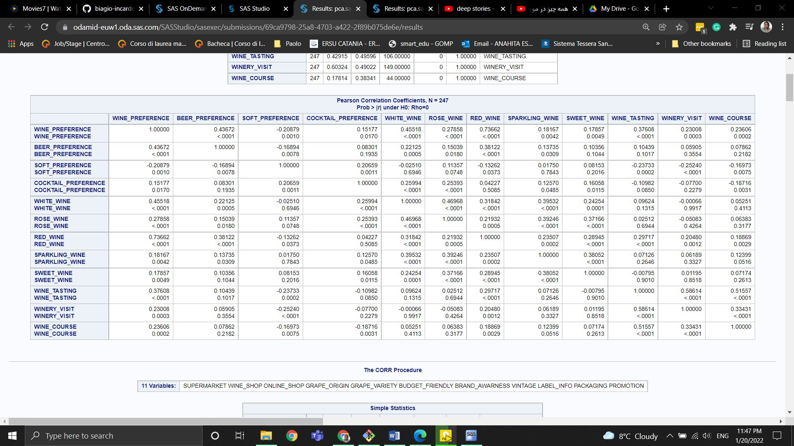



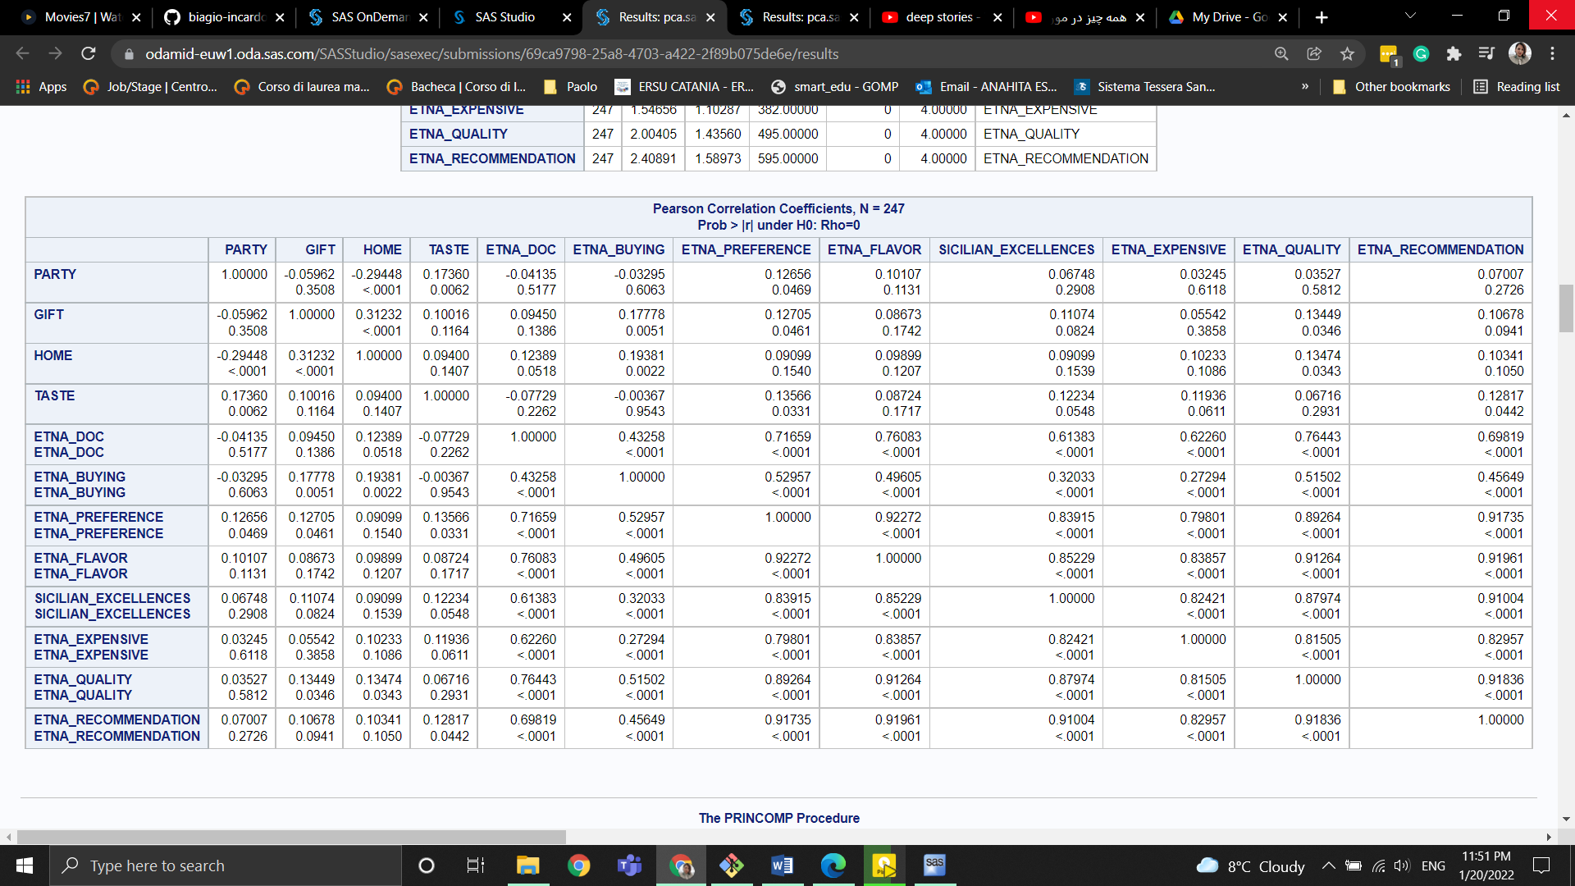

Then we need to find eigenvalue of each variable.

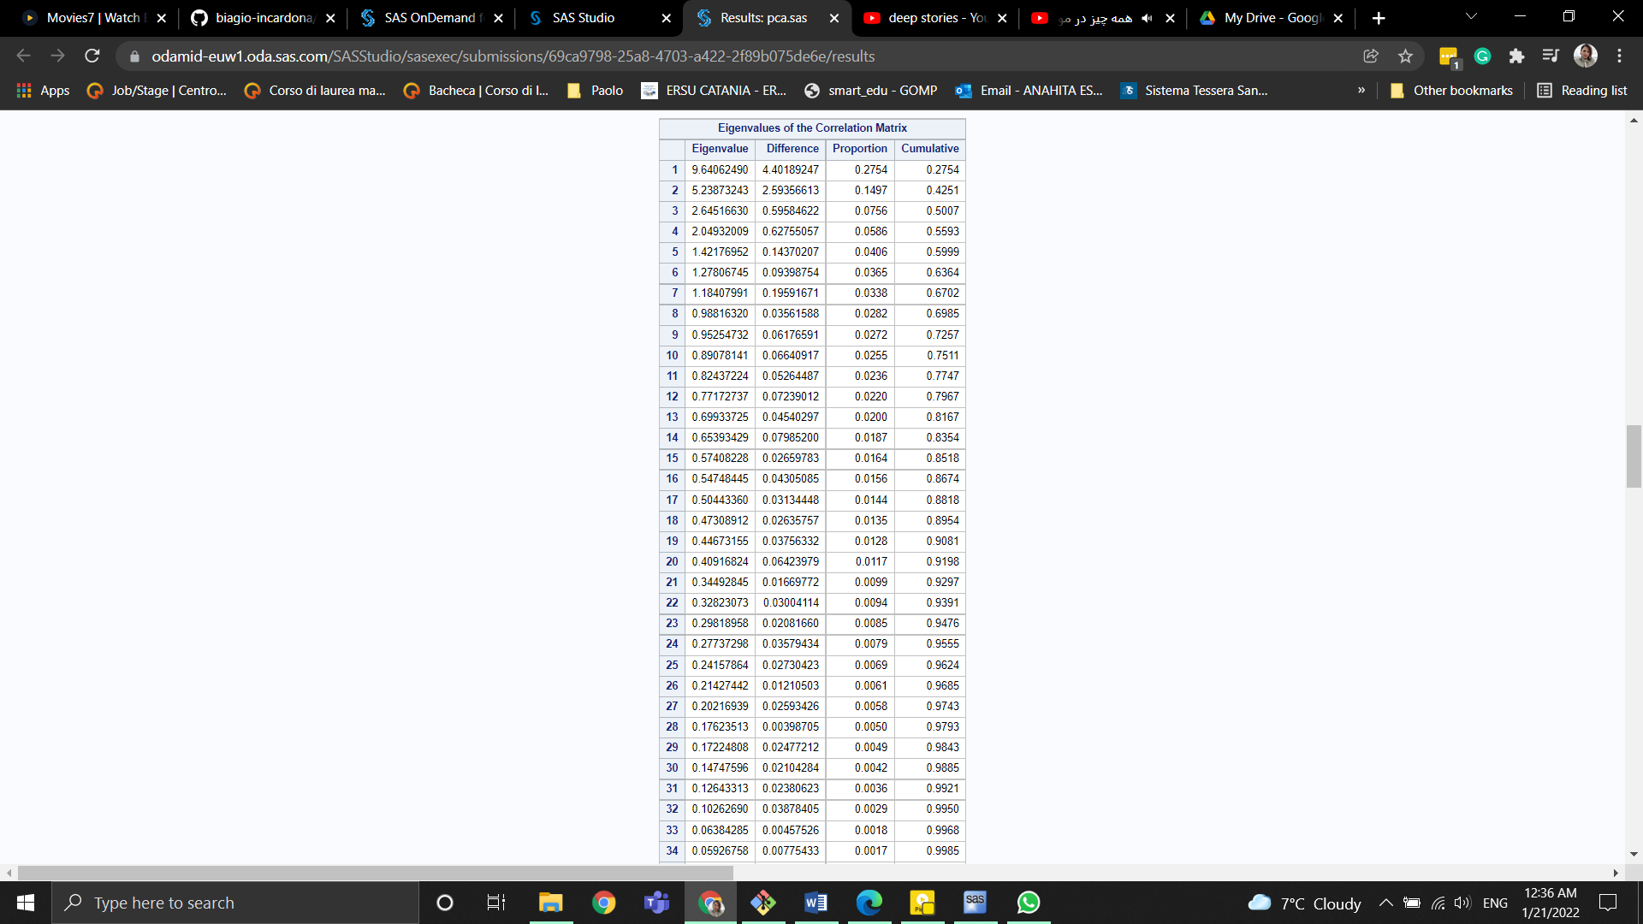

In order to choose how many Principal Components to keep, the eigenvalue associated with each component is considered. Only components with an eigenvalue > 1 will be kept. So we decide to keep the only 7 principal components.

The eigenvector of these 7 principal componets are as follow:

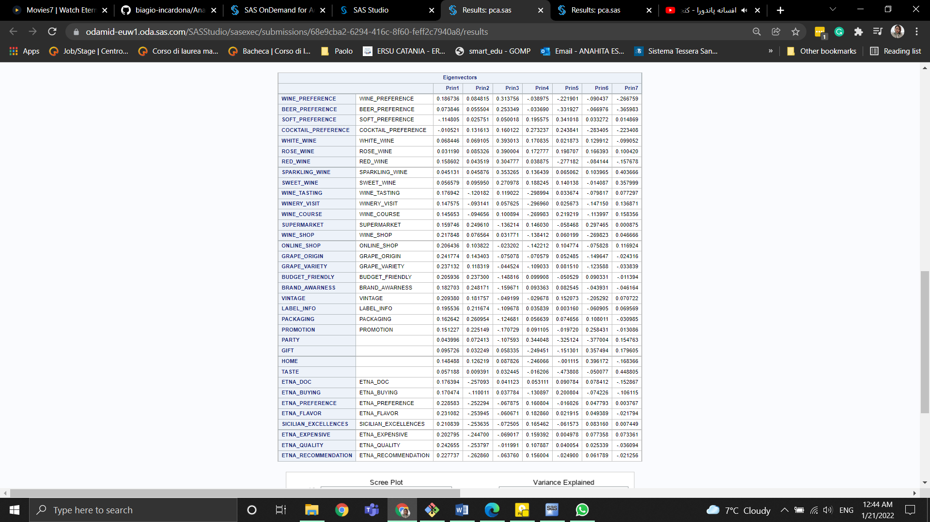

Based on scree plot we need 5 pca.

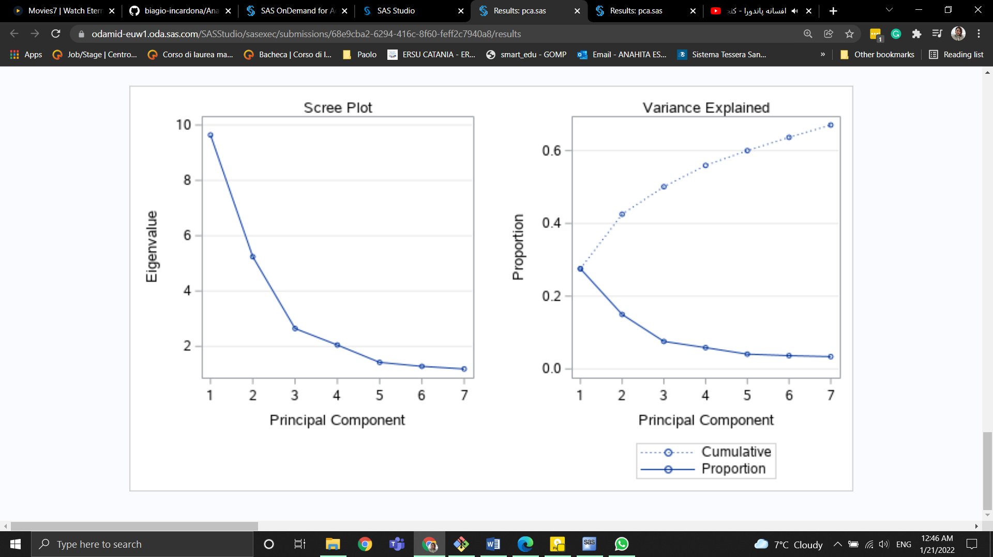

From the correlation matrix of Principal Components and the original variables, it seems that the first PC is more positively correlated with etna_quality, grape_variety, grape_origin. The second principal component is correlated with packaging, brand_awarness, supermarket. The third principal component is correlated with white_wine, rose_wine, sparkling_wine. Even if the first three principal components make sense, it is difficult to interpret the others.

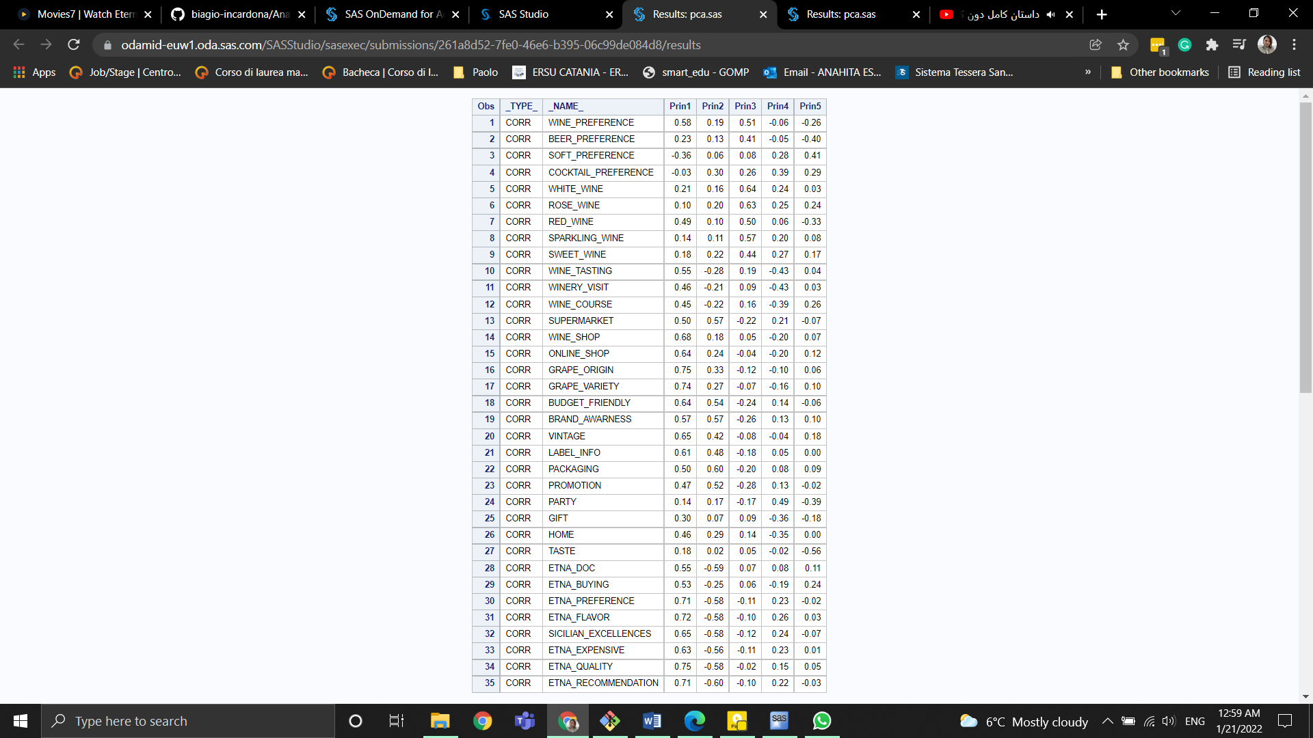

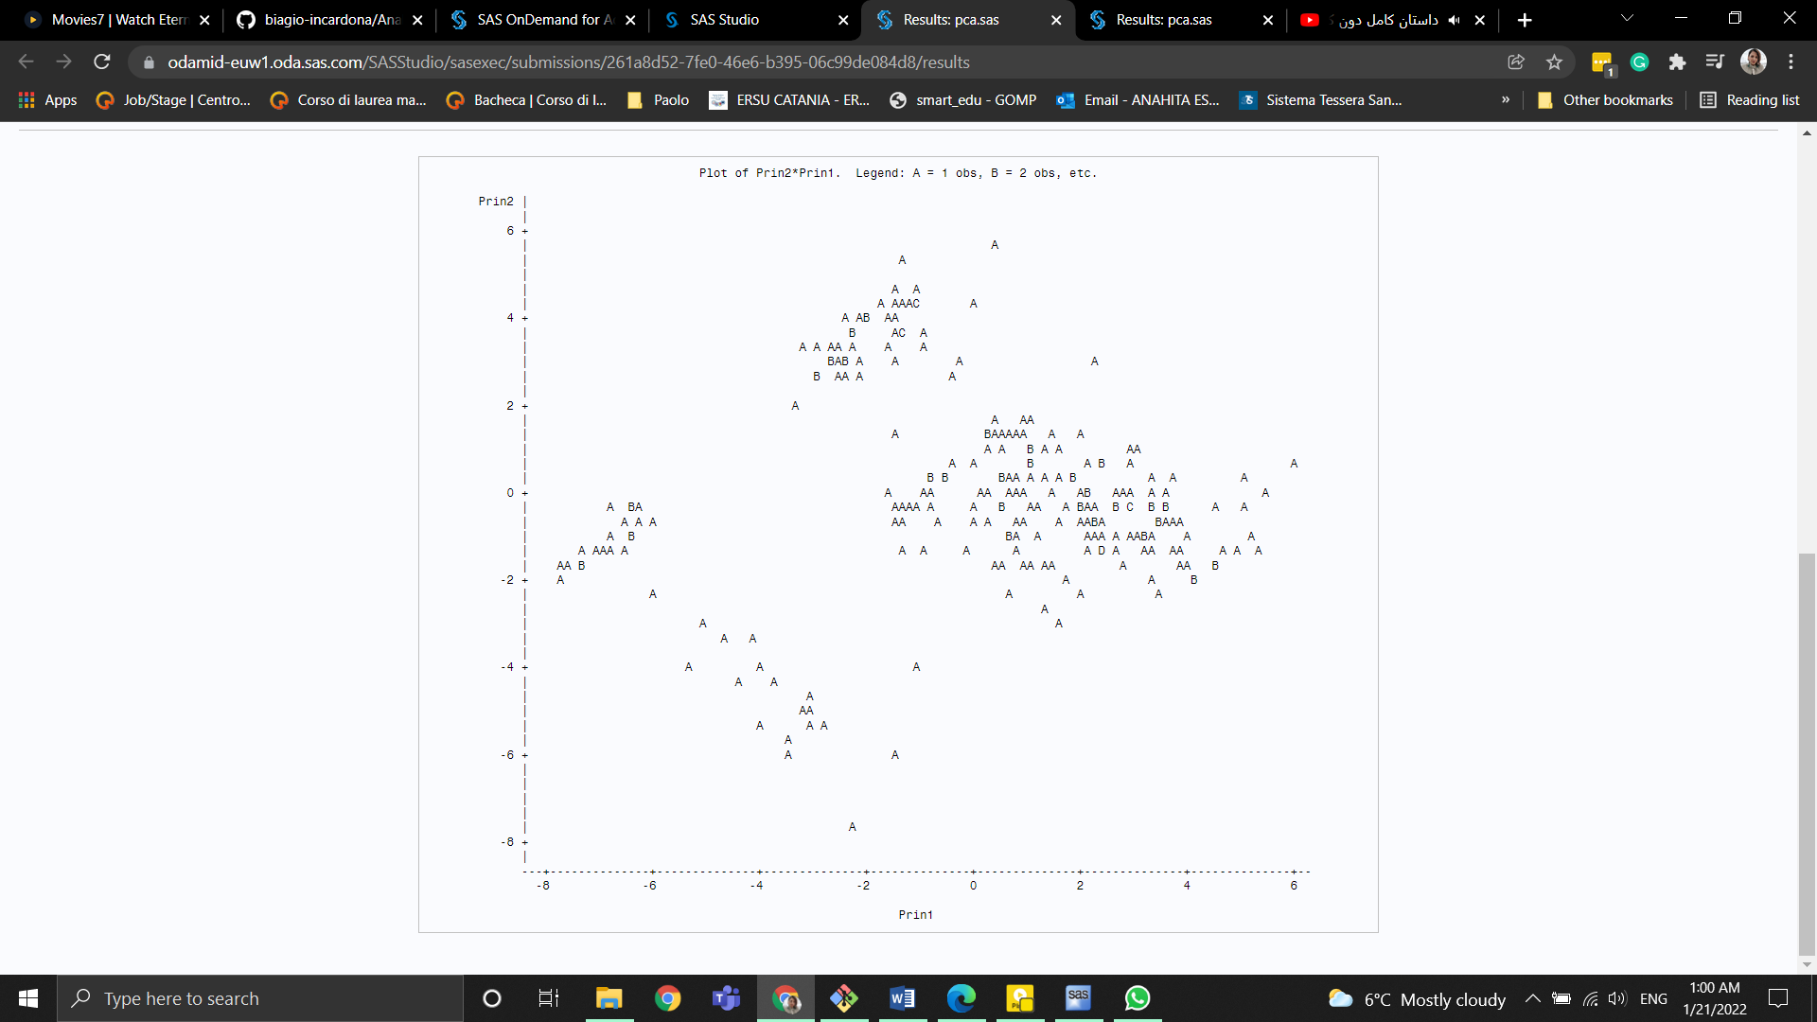

## Factor Analysis

## IRT- Item Response Theory

Item response theory (IRT) is a paradigm for the analysis, and scoring of tests, questionnaires, and similar instruments measuring abilities, attitudes, or other factors. IRT is a theory of testing based on the relationship between individuals’ performances on a test item and the test takers’ levels of performance on an overall measure of the ability that item was designed to measure. IRT is based on the idea that the probability of a correct/keyed response to an item is a mathematical function of person and item parameters. The first parameter affecting the item reponses of an item is the respondent’s level on the latent train that item is trying to evaluate, other factors can be the difficulty level (how much of skills/satisfaction is needed to respond in a correct/positive way), the discrimination power (how good is the item in discriminating between individuals with different levels of the latent trait) and the easiness of guessing of a certain item.

Item Response Theory is based on 4 main assumptions:

1. Monotonicity: if the trait level increases, the probability of a correct/positive reponse increases as well

2. Unidimensionality: there is one dominant latent trait that is measured and this trait is the driving force for the responses observed for each item

3. Local Independence: the responses for an item don’t affect the responses for other items

There are 3 main steps in applying an IRT analysis: model selection, estimation of the parameters and estimation of the abilities of the respondent.

Initially IRT will be applied to the whole dataset in order to have an overall look on the items’ difficulty, then it will be applied onto the subgrops of items extrapolated from the original questionnaire.

### **4.5.1 Dataset level IRT**

In this first step, IRT will be applied to all the items together, except for the socio-demographic items (GENDER, AGE, EDUCATION, LOCATION, JOB) since for these items doesn’t make any sense to try studying their difficulties (in this context).

In the following SAS procedure, all the default options will be used. The Marginal Maximum Likelihood estimation method will be used to estimate the parameters of the Graded Response Model (which, for binary items, became the two Parameter Logistic Model). This model expresses the probability of responding in a certain way as a function of the properties of both the item and the individual’s latent trait.

Let’s start by seeing if there is only one dominant latent trait that drives the responses observed for each factor. To do that we can use the following scree plot of the eigenvalues and the subsequent table:



Let’s start by seeing if there is only one dominant latent trait that drives the responses observed for each factor. To do that we can use the following scree plot of the eigenvalues and the subsequent table: 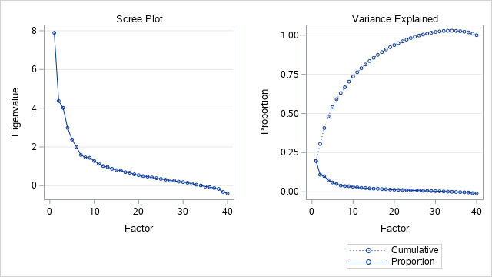

As we can see from the images above the first eigen value is much higher than the others and it explains almost the 25% of the total variabilty, hence the model hypothesis is satisfied and so a unidimensional model is reasonable in this example.

Now we can have a look at the parameter estimations, in doing this we will focus on the threshold parameter, which represent the difficulty of the items (the higher the threshold the higher the difficulty of that item) and also on the slope, which is the discrimination parameter (the higher the slope the better the item is in differentiating subjects), actually the value of the slope represents also the amount of information provided by a certain item, hence items with an higher slope are more informative than items with a lower slope.

To preserve the reader's eyes all the easier items will be higlighted in Green, the harder will be highlited in Red, and the one with higher discrimination power will be highlited in Yellow.

| **Item Parameter Estimates** | | | | | | |
| --- | --- | --- | --- | --- | --- | --- |
| **Response Model** | **Item** | **Label** | **Parameter** | **Estimate** | **Standard Error** | **Pr > |t|** |
| **Graded** | **WINE_PREFERENCE** | WINE_PREFERENCE | **Threshold 1** | -1.59165 | 0.16129 | <.0001 |
|  |  |  | **Threshold 2** | -0.86753 | 0.10868 | <.0001 |
|  |  |  | **Threshold 3** | 0.03422 | 0.09345 | 0.3571 |
|  |  |  | **Slope** | 2.83221 | 0.45968 | <.0001 |
|  | **BEER_PREFERENCE** | BEER_PREFERENCE | **Threshold 1** | -2.65182 | 0.59002 | <.0001 |
|  |  |  | **Threshold 2** | -0.82768 | 0.27311 | 0.0012 |
|  |  |  | **Threshold 3** | 1.15645 | 0.31895 | 0.0001 |
|  |  |  | **Slope** | 0.64378 | 0.14165 | <.0001 |
|  | **SOFT_PREFERENCE** | SOFT_PREFERENCE | **Threshold 1** | 2.78856 | 0.66241 | <.0001 |
|  |  |  | **Threshold 2** | 0.20342 | 0.24532 | 0.2035 |
|  |  |  | **Threshold 3** | -1.95424 | 0.49841 | <.0001 |
|  |  |  | **Slope** | -0.56110 | 0.13133 | <.0001 |
|  | **COCKTAIL_PREFERENCE** | COCKTAIL_PREFERENCE | **Threshold 1** | 39.62510 | 142.48227 | 0.3905 |
|  |  |  | **Threshold 2** | 2.65780 | 10.14578 | 0.3967 |
|  |  |  | **Threshold 3** | -31.50778 | 113.46249 | 0.3906 |
|  |  |  | **Slope** | -0.03403 | 0.12249 | 0.3906 |
|  | **WHITE_WINE** | WHITE_WINE | **Threshold 1** | -3.54161 | 0.80711 | <.0001 |
|  |  |  | **Threshold 2** | -1.16692 | 0.33262 | 0.0002 |
|  |  |  | **Threshold 3** | 1.59408 | 0.40163 | <.0001 |
|  |  |  | **Slope** | 0.62935 | 0.14370 | <.0001 |
|  | **ROSE_WINE** | ROSE_WINE | **Threshold 1** | -3.62641 | 1.23381 | 0.0016 |
|  |  |  | **Threshold 2** | 0.78172 | 0.41878 | 0.0310 |
|  |  |  | **Threshold 3** | 4.78673 | 1.60011 | 0.0014 |
|  |  |  | **Slope** | 0.38825 | 0.12966 | 0.0014 |
|  | **RED_WINE** | RED_WINE | **Threshold 1** | -1.79584 | 0.23083 | <.0001 |
|  |  |  | **Threshold 2** | -0.84169 | 0.14423 | <.0001 |
|  |  |  | **Threshold 3** | 0.54945 | 0.13461 | <.0001 |
|  |  |  | **Slope** | 1.53415 | 0.22547 | <.0001 |
|  | **SPARKLING_WINE** | SPARKLING_WINE | **Threshold 1** | -3.29599 | 1.07951 | 0.0011 |
|  |  |  | **Threshold 2** | -0.39311 | 0.35327 | 0.1329 |
|  |  |  | **Threshold 3** | 3.63559 | 1.17117 | 0.0010 |
|  |  |  | **Slope** | 0.39789 | 0.12643 | 0.0008 |
|  | **SWEET_WINE** | SWEET_WINE | **Threshold 1** | -2.62255 | 1.00459 | 0.0045 |
|  |  |  | **Threshold 2** | 1.04644 | 0.50787 | 0.0197 |
|  |  |  | **Threshold 3** | 4.43376 | 1.59291 | 0.0027 |
|  |  |  | **Slope** | 0.35040 | 0.12554 | 0.0026 |
|  | **WINE_KNOWLEDGE** | WINE_KNOWLEDGE | **Threshold 1** | -0.67394 | 0.12467 | <.0001 |
|  |  |  | **Threshold 2** | 1.57147 | 0.18934 | <.0001 |
|  |  |  | **Threshold 3** | 1.69023 | 0.20065 | <.0001 |
|  |  |  | **Slope** | 1.70662 | 0.23243 | <.0001 |
|  | **BUYING_EXPERIENCE** | BUYING_EXPERIENCE | **Threshold 1** | -0.92988 | 0.22021 | <.0001 |
|  |  |  | **Threshold 2** | -2.60706 | 0.50161 | <.0001 |
|  |  |  | **Threshold 3** | -3.30831 | 0.66036 | <.0001 |
|  |  |  | **Threshold 4** | -4.62985 | 0.99061 | <.0001 |
|  |  |  | **Threshold 5** | -4.82015 | 1.04294 | <.0001 |
|  |  |  | **Slope** | -0.82683 | 0.17443 | <.0001 |
|  | **WINE_BOTTLES** | WINE_BOTTLES | **Threshold 1** | -1.18017 | 0.17053 | <.0001 |
|  |  |  | **Threshold 2** | -0.79653 | 0.14456 | <.0001 |
|  |  |  | **Threshold 3** | 0.95395 | 0.15407 | <.0001 |
|  |  |  | **Threshold 4** | 1.82755 | 0.22763 | <.0001 |
|  |  |  | **Threshold 5** | 2.35593 | 0.29193 | <.0001 |
|  |  |  | **Threshold 6** | 3.00070 | 0.39811 | <.0001 |
|  |  |  | **Slope** | 1.43101 | 0.19037 | <.0001 |
|  | **SUPERMARKET** | SUPERMARKET | **Threshold 1** | 6.01085 | 2.00352 | 0.0013 |
|  |  |  | **Threshold 2** | 2.78711 | 0.98738 | 0.0024 |
|  |  |  | **Threshold 3** | -1.72351 | 0.61566 | 0.0026 |
|  |  |  | **Slope** | -0.40504 | 0.13528 | 0.0014 |
|  | **WINE_SHOP** | WINE_SHOP | **Threshold 1** | -1.36555 | 0.27511 | <.0001 |
|  |  |  | **Threshold 2** | 1.49949 | 0.30453 | <.0001 |
|  |  |  | **Threshold 3** | 3.30606 | 0.57655 | <.0001 |
|  |  |  | **Slope** | 0.80991 | 0.14654 | <.0001 |
|  | **ONLINE_SHOP** | ONLINE_SHOP | **Threshold 1** | 1.71124 | 0.24675 | <.0001 |
|  |  |  | **Threshold 2** | 2.64462 | 0.38779 | <.0001 |
|  |  |  | **Threshold 3** | 3.92050 | 0.67427 | <.0001 |
|  |  |  | **Slope** | 1.37631 | 0.25431 | <.0001 |
|  | **GRAPE_ORIGIN** | GRAPE_ORIGIN | **Threshold 1** | -3.54765 | 0.69959 | <.0001 |
|  |  |  | **Threshold 2** | -1.68537 | 0.34120 | <.0001 |
|  |  |  | **Threshold 3** | 1.40101 | 0.31619 | <.0001 |
|  |  |  | **Slope** | 0.75927 | 0.14747 | <.0001 |
|  | **GRAPE_VARIETY** | GRAPE_VARIETY | **Threshold 1** | -2.89396 | 0.55587 | <.0001 |
|  |  |  | **Threshold 2** | -1.31580 | 0.27748 | <.0001 |
|  |  |  | **Threshold 3** | 1.74595 | 0.35360 | <.0001 |
|  |  |  | **Slope** | 0.79652 | 0.15153 | <.0001 |
|  | **BUDGET_FRIENDLY** | BUDGET_FRIENDLY | **Threshold 1** | 209.77422 | 1669 | 0.4500 |
|  |  |  | **Threshold 2** | 94.36399 | 751.44903 | 0.4500 |
|  |  |  | **Threshold 3** | -54.91275 | 436.51871 | 0.4499 |
|  |  |  | **Slope** | -0.01619 | 0.12885 | 0.4500 |
|  | **BRAND_AWARNESS** | BRAND_AWARNESS | **Threshold 1** | 8.29808 | 3.74706 | 0.0134 |
|  |  |  | **Threshold 2** | 3.78289 | 1.75350 | 0.0155 |
|  |  |  | **Threshold 3** | -5.32198 | 2.38460 | 0.0128 |
|  |  |  | **Slope** | -0.29052 | 0.13132 | 0.0135 |
|  | **VINTAGE** | VINTAGE | **Threshold 1** | -3.01494 | 0.73493 | <.0001 |
|  |  |  | **Threshold 2** | 1.54781 | 0.44167 | 0.0002 |
|  |  |  | **Threshold 3** | 3.47411 | 0.84594 | <.0001 |
|  |  |  | **Slope** | 0.54007 | 0.13171 | <.0001 |
|  | **LABEL_INFO** | LABEL_INFO | **Threshold 1** | 13.67609 | 11.88621 | 0.1250 |
|  |  |  | **Threshold 2** | 4.21622 | 3.81859 | 0.1348 |
|  |  |  | **Threshold 3** | -10.12689 | 8.71877 | 0.1227 |
|  |  |  | **Slope** | -0.14228 | 0.12337 | 0.1244 |
|  | **PACKAGING** | PACKAGING | **Threshold 1** | 19.57622 | 30.90542 | 0.2632 |
|  |  |  | **Threshold 2** | -10.11127 | 15.86080 | 0.2619 |
|  |  |  | **Threshold 3** | -27.62187 | 43.44567 | 0.2625 |
|  |  |  | **Slope** | -0.08080 | 0.12707 | 0.2624 |
|  | **PROMOTION** | PROMOTION | **Threshold 1** | 7.78455 | 5.64390 | 0.0839 |
|  |  |  | **Threshold 2** | -4.49819 | 3.23816 | 0.0824 |
|  |  |  | **Threshold 3** | -9.77802 | 7.00982 | 0.0815 |
|  |  |  | **Slope** | -0.17566 | 0.12590 | 0.0815 |
|  | **BOTTLE_BUDGET** | BOTTLE_BUDGET | **Threshold 1** | -8.15993 | 10.05835 | 0.2086 |
|  |  |  | **Threshold 2** | -16.25513 | 20.06395 | 0.2089 |
|  |  |  | **Threshold 3** | -25.74326 | 31.88792 | 0.2097 |
|  |  |  | **Slope** | -0.13231 | 0.16395 | 0.2098 |
|  | **BUYING_FREQUENCY** | BUYING_FREQUENCY | **Threshold 1** | -11.77202 | 8.35868 | 0.0795 |
|  |  |  | **Threshold 2** | -9.06877 | 6.42516 | 0.0791 |
|  |  |  | **Threshold 3** | 6.22357 | 4.46522 | 0.0817 |
|  |  |  | **Threshold 4** | 15.42351 | 10.99089 | 0.0803 |
|  |  |  | **Slope** | 0.18333 | 0.13052 | 0.0801 |
|  | **ETNA_BUYING** | ETNA_BUYING | **Threshold 1** | -2.00352 | 0.26918 | <.0001 |
|  |  |  | **Threshold 2** | 0.26302 | 0.13089 | 0.0222 |
|  |  |  | **Slope** | 1.43941 | 0.22011 | <.0001 |
|  | **ETNA_PREFERENCE** | ETNA_PREFERENCE | **Threshold 1** | 1166 | 66158 | 0.4930 |
|  |  |  | **Threshold 2** | 432.39270 | 24529 | 0.4930 |
|  |  |  | **Threshold 3** | -1099 | 62369 | 0.4930 |
|  |  |  | **Slope** | -0.00263 | 0.14916 | 0.4930 |
|  | **ETNA_FLAVOR** | ETNA_FLAVOR | **Threshold 1** | -8.46354 | 3.30396 | 0.0052 |
|  |  |  | **Threshold 2** | -4.25854 | 1.61658 | 0.0042 |
|  |  |  | **Threshold 3** | 4.39410 | 1.69737 | 0.0048 |
|  |  |  | **Slope** | 0.40927 | 0.15898 | 0.0050 |
|  | **SICILIAN_EXCELLENCES** | SICILIAN_EXCELLENCES | **Threshold 1** | -5.91337 | 1.79720 | 0.0005 |
|  |  |  | **Threshold 2** | -4.18552 | 1.24789 | 0.0004 |
|  |  |  | **Threshold 3** | 2.96824 | 0.90152 | 0.0005 |
|  |  |  | **Slope** | 0.50614 | 0.15423 | 0.0005 |
|  | **ETNA_EXPENSIVE** | ETNA_EXPENSIVE | **Threshold 1** | -4.49612 | 1.31150 | 0.0003 |
|  |  |  | **Threshold 2** | 3.33060 | 0.97242 | 0.0003 |
|  |  |  | **Threshold 3** | 6.90742 | 2.04994 | 0.0004 |
|  |  |  | **Slope** | 0.53546 | 0.16098 | 0.0004 |
|  | **ETNA_QUALITY** | ETNA_QUALITY | **Threshold 1** | -3.63592 | 0.63831 | <.0001 |
|  |  |  | **Threshold 2** | -1.85019 | 0.29658 | <.0001 |
|  |  |  | **Threshold 3** | 1.65212 | 0.27171 | <.0001 |
|  |  |  | **Slope** | 1.08537 | 0.18407 | <.0001 |
|  | **ETNA_RECOMMENDATION** | ETNA_RECOMMENDATION | **Threshold 1** | 66.97502 | 184.43214 | 0.3582 |
|  |  |  | **Threshold 2** | 47.31564 | 130.15830 | 0.3581 |
|  |  |  | **Threshold 3** | 18.91056 | 51.96661 | 0.3580 |
|  |  |  | **Slope** | -0.05795 | 0.15959 | 0.3583 |
| **TwoP** | **WINE_TASTING** | WINE_TASTING | **Difficulty** | 0.17557 | 0.10649 | 0.0496 |
|  |  |  | **Slope** | 2.11417 | 0.34795 | <.0001 |
|  | **WINERY_VISIT** | WINERY_VISIT | **Difficulty** | -0.43781 | 0.12847 | 0.0003 |
|  |  |  | **Slope** | 1.43703 | 0.26620 | <.0001 |
|  | **WINE_COURSE** | WINE_COURSE | **Difficulty** | 1.21970 | 0.15715 | <.0001 |
|  |  |  | **Slope** | 2.06060 | 0.36829 | <.0001 |
|  | **PARTY** |  | **Difficulty** | -10.33400 | 12.87826 | 0.2111 |
|  |  |  | **Slope** | -0.14595 | 0.18279 | 0.2123 |
|  | **GIFT** |  | **Difficulty** | 1.69885 | 0.42342 | <.0001 |
|  |  |  | **Slope** | 0.69337 | 0.17282 | <.0001 |
|  | **HOME** |  | **Difficulty** | -0.44917 | 0.14870 | 0.0013 |
|  |  |  | **Slope** | 1.15444 | 0.21601 | <.0001 |
|  | **TASTE** |  | **Difficulty** | 5.00236 | 2.28163 | 0.0142 |
|  |  |  | **Slope** | 0.47359 | 0.22905 | 0.0193 |
|  | **ETNA_DOC** | ETNA_DOC | **Difficulty** | -0.26353 | 0.13698 | 0.0272 |
|  |  |  | **Slope** | 1.21552 | 0.22333 | <.0001 |

According to the table above we can identify the easiest and the hardest items. Let’s start with the easiest ones:

* Packaging
* Bottle_Budget
* Buying_Frequency
* Party

Now let’s see the hardest ones:

* Cocktail_Preference
* Budget_Friendly
* Label_Info
* Etna_Preference
* Etna_Recommendation

Now let’s analize also the slope parameter, which represents the discrimination parameter. Recalling that the slope parameter identifies the amount of information described by each item we can analize it looking at the following information curves:





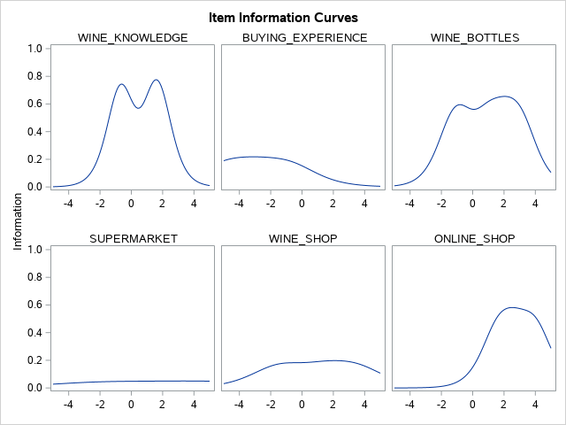





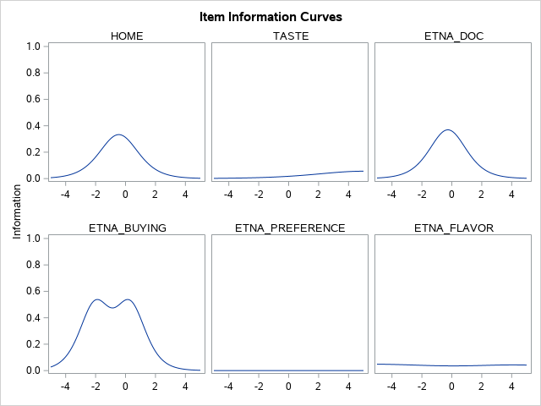



The first thing that we can notice from these plots is that very few items are informative for subjects with a really high or really low latent trait ablity.

Another thing that can be seen by these plots is that all the items identified as easy and hard provide little to no information at all . We can try to remove all these items because they are not general enough and do not provide any sort of information.

As we can see in the images below the item test curve do not change at all after the removal of these items.

It comes straightforward to notice that the test is not informative for those subjects whose latent trait level is very distant from the difficulty level of the items

### **4.5.2 IRT on topics**

Now that we have seen the properties of the various items at a global level, we can focus on each subgroup of items, identified by each topic of our questionnaire.

In the questionnaire there are 3 main topics:

1. Wine preferences, expertise and experience
2. Wine buying experience
3. Etna DOC Wine

and 1 socio-demographic topic that we will ignore.

For each topic the same approach of the global level IRT will be used.

#### **4.5.2.1 Wine preferences, expertise and experience**

From the following scree plot we can identify that there is only one latent trait guiding the responses



Let’s have a look at the estimated parameters

| **Item Parameter Estimates** | | | | | | |
| --- | --- | --- | --- | --- | --- | --- |
| **Response Model** | **Item** | **Label** | **Parameter** | **Estimate** | **Standard Error** | **Pr > |t|** |
| **Graded** | **WINE_PREFERENCE** | WINE_PREFERENCE | **Threshold 1** | -1.50560 | 0.13448 | <.0001 |
|  |  |  | **Threshold 2** | -0.70713 | 0.09534 | <.0001 |
|  |  |  | **Threshold 3** | 0.11362 | 0.08044 | 0.0789 |
|  |  |  | **Slope** | 5.69107 | 1.66047 | 0.0003 |
|  | **BEER_PREFERENCE** | BEER_PREFERENCE | **Threshold 1** | -1.91935 | 0.32388 | <.0001 |
|  |  |  | **Threshold 2** | -0.60688 | 0.17825 | 0.0003 |
|  |  |  | **Threshold 3** | 0.82403 | 0.19782 | <.0001 |
|  |  |  | **Slope** | 0.96219 | 0.15966 | <.0001 |
|  | **SOFT_PREFERENCE** | SOFT_PREFERENCE | **Threshold 1** | 3.50717 | 1.06623 | 0.0005 |
|  |  |  | **Threshold 2** | 0.24857 | 0.31266 | 0.2133 |
|  |  |  | **Threshold 3** | -2.47245 | 0.78526 | 0.0008 |
|  |  |  | **Slope** | -0.43257 | 0.13042 | 0.0005 |
|  | **COCKTAIL_PREFERENCE** | COCKTAIL_PREFERENCE | **Threshold 1** | -6.87997 | 4.51098 | 0.0636 |
|  |  |  | **Threshold 2** | -0.42631 | 0.71702 | 0.2761 |
|  |  |  | **Threshold 3** | 5.51072 | 3.61579 | 0.0637 |
|  |  |  | **Slope** | 0.19615 | 0.12740 | 0.0618 |
|  | **WHITE_WINE** | WHITE_WINE | **Threshold 1** | -2.35695 | 0.35912 | <.0001 |
|  |  |  | **Threshold 2** | -0.76947 | 0.17923 | <.0001 |
|  |  |  | **Threshold 3** | 1.06039 | 0.20534 | <.0001 |
|  |  |  | **Slope** | 1.05185 | 0.16464 | <.0001 |
|  | **ROSE_WINE** | ROSE_WINE | **Threshold 1** | -2.29161 | 0.50341 | <.0001 |
|  |  |  | **Threshold 2** | 0.50536 | 0.23352 | 0.0152 |
|  |  |  | **Threshold 3** | 3.00009 | 0.64319 | <.0001 |
|  |  |  | **Slope** | 0.64874 | 0.13767 | <.0001 |
|  | **RED_WINE** | RED_WINE | **Threshold 1** | -1.48574 | 0.15549 | <.0001 |
|  |  |  | **Threshold 2** | -0.64289 | 0.10826 | <.0001 |
|  |  |  | **Threshold 3** | 0.46628 | 0.10121 | <.0001 |
|  |  |  | **Slope** | 2.51156 | 0.32044 | <.0001 |
|  | **SPARKLING_WINE** | SPARKLING_WINE | **Threshold 1** | -2.48933 | 0.63269 | <.0001 |
|  |  |  | **Threshold 2** | -0.30987 | 0.25859 | 0.1154 |
|  |  |  | **Threshold 3** | 2.71771 | 0.68172 | <.0001 |
|  |  |  | **Slope** | 0.54458 | 0.13307 | <.0001 |
|  | **SWEET_WINE** | SWEET_WINE | **Threshold 1** | -1.71241 | 0.47612 | 0.0002 |
|  |  |  | **Threshold 2** | 0.70333 | 0.28704 | 0.0071 |
|  |  |  | **Threshold 3** | 2.90880 | 0.72076 | <.0001 |
|  |  |  | **Slope** | 0.55342 | 0.13584 | <.0001 |
|  | **WINE_KNOWLEDGE** | WINE_KNOWLEDGE | **Threshold 1** | -0.75610 | 0.16687 | <.0001 |
|  |  |  | **Threshold 2** | 1.87656 | 0.27827 | <.0001 |
|  |  |  | **Threshold 3** | 2.01532 | 0.29694 | <.0001 |
|  |  |  | **Slope** | 1.21819 | 0.19507 | <.0001 |
| **TwoP** | **WINE_TASTING** | WINE_TASTING | **Difficulty** | 0.29448 | 0.13185 | 0.0128 |
|  |  |  | **Slope** | 1.33426 | 0.24456 | <.0001 |
|  | **WINERY_VISIT** | WINERY_VISIT | **Difficulty** | -0.61752 | 0.22668 | 0.0032 |
|  |  |  | **Slope** | 0.75703 | 0.17666 | <.0001 |
|  | **WINE_COURSE** | WINE_COURSE | **Difficulty** | 1.51179 | 0.26747 | <.0001 |
|  |  |  | **Slope** | 1.30343 | 0.29295 | <.0001 |

This section doesn’t seem to have neither too easy itmes nor to difficult ones, the only item that have more “extreme” threshold values is Cocktail_Preference, but also here the values are relatively balanced.

Let’s see how the discrimination values behave







As we can see here half of the items provide a small contribution to the analysis and 3 of them apport litteraly 0 contribution. Let’s see if we can remove those 3 items without losing information



As we can clearly see, the shape remains almost the same, hence it can make sense to remove these items from this topic. Must be noted that with these items the test is almost not informative for the subjects with a latent trait far away from the difficulty level.

#### **4.5.2.2 Wine buying experience**

The items that fall into this topic are:

* BUYING_EXPERIENCE
* WINE_BOTTLES
* SUPERMARKET
* WINE_SHOP
* ONLINE_SHOP
* GRAPE_ORIGIN
* GRAPE_VARIETY
* BUDGET_FRIENDLY
* BRAND_AWARNESS
* VINTAGE
* LBEL_INFO
* PACKAGING
* PROMOTION
* BOTTLE_BUDGET
* BUYING_FREQUENCY
* PARTY
* GIFT
* HOME
* TASTE

Analize the scree plot for this topic we find out that there are more than one driving force that influece the responses of the subjects (we can identify that considering that the first two eigenvalues are really close).

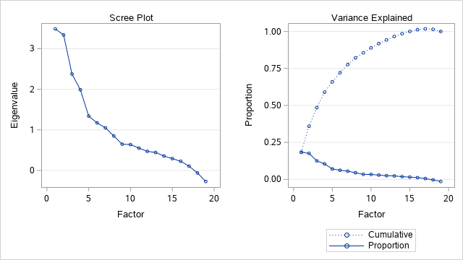

Let’s check how the items relate to each of the 2 main factors.

| **Rotated Slope Matrix** | | |
| --- | --- | --- |
|  | **_Factor1** | **_Factor2** |
| **BUYING_EXPERIENCE** | -0.28159 | 0.76757 |
| **WINE_BOTTLES** | 0.31072 | 0.52798 |
| **SUPERMARKET** | -1.55931 | 0.14830 |
| **WINE_SHOP** | 2.14141 | -0.23166 |
| **ONLINE_SHOP** | 0.89898 | 0.01597 |
| **GRAPE_ORIGIN** | 1.22596 | -0.78631 |
| **GRAPE_VARIETY** | 1.42912 | -0.47651 |
| **BUDGET_FRIENDLY** | -0.96266 | -0.48930 |
| **BRAND_AWARNESS** | -0.86122 | -1.54697 |
| **VINTAGE** | 0.46446 | -1.09839 |
| **LABEL_INFO** | -0.19131 | -0.97166 |
| **PACKAGING** | -0.79830 | -0.56321 |
| **PROMOTION** | -1.19528 | -0.20459 |
| **BOTTLE_BUDGET** | -0.46467 | 1.66485 |
| **BUYING_FREQUENCY** | -0.14678 | 0.28150 |
| **PARTY** | -0.53597 | -0.06288 |
| **GIFT** | 0.23626 | 0.43151 |
| **HOME** | 0.17032 | 0.71065 |
| **TASTE** | -0.02893 | 1.18769 |

In order to be sure of this division of the items let’s apply a confirmatory model.

| **Slope Matrix Estimate/StdErr/p-value** | | |
| --- | --- | --- |
|  | **Factor1** | **Factor2** |
| **BUYING_EXPERIENCE** | 0.00000 | 0.51159  0.16259  0.00083 |
| **WINE_BOTTLES** | 0.00000 | -3.15877  0.88804  0.00019 |
| **SUPERMARKET** | 1.57173  0.24741  <.00001 | 0.00000 |
| **WINE_SHOP** | -2.47685  0.43741  <.00001 | 0.00000 |
| **ONLINE_SHOP** | -0.75966  0.25050  0.00121 | 0.00000 |
| **GRAPE_ORIGIN** | -1.15961  0.19908  <.00001 | 0.00000 |
| **GRAPE_VARIETY** | -1.36410  0.21743  <.00001 | 0.00000 |
| **BUDGET_FRIENDLY** | 0.80295  0.18155  <.00001 | 0.00000 |
| **BRAND_AWARNESS** | 0.00000 | 0.60214  0.15489  0.00005 |
| **VINTAGE** | 0.00000 | 0.04228  0.13616  0.37808 |
| **LABEL_INFO** | 0.00000 | 0.52122  0.13569  0.00006 |
| **PACKAGING** | 0.73185  0.16471  <.00001 | 0.00000 |
| **PROMOTION** | 1.15712  0.19748  <.00001 | 0.00000 |
| **BOTTLE_BUDGET** | 0.00000 | -0.94409  0.24067  0.00004 |
| **BUYING_FREQUENCY** | 0.00000 | -0.42096  0.14295  0.00162 |
| **PARTY** | 0.46113  0.19479  0.00896 | 0.00000 |
| **GIFT** | 0.00000 | -1.01689  0.24712  0.00002 |
| **HOME** | 0.00000 | -3.05037  0.84937  0.00016 |
| **TASTE** | 0.00000 | -1.07522  0.35512  0.00123 |

As we can see, with a 0.05 confidence level, all our “classifications” are statistically significant but one: Vintage.

Re-running the test but assignign Vintage to the first factor we get that it has a slope matrix estimate of -0.58537 with a standard error of 0.15893 and a P-Value of 0.00012, therefore we can assign Vintage to the first factor.

Let’s run IRT individually on each of these factors.

#### **4.5.2.3 Factor1**

Let’s start by the classical check of the eigenvalues (even though we have already tested it)

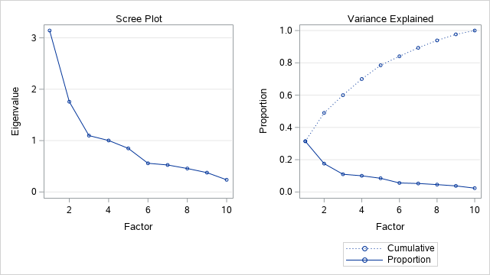

Clearly now one single latent trait drives all the answers in this subgroup.

Let’s have a look at the parameters.

| **Item Parameter Estimates** | | | | | | |
| --- | --- | --- | --- | --- | --- | --- |
| **Response Model** | **Item** | **Label** | **Parameter** | **Estimate** | **Standard Error** | **Pr > |t|** |
| **Graded** | **SUPERMARKET** | SUPERMARKET | **Threshold 1** | -2.05123 | 0.26609 | <.0001 |
|  |  |  | **Threshold 2** | -1.00052 | 0.15790 | <.0001 |
|  |  |  | **Threshold 3** | 0.55497 | 0.13506 | <.0001 |
|  |  |  | **Slope** | 1.55504 | 0.24064 | <.0001 |
|  | **WINE_SHOP** | WINE_SHOP | **Threshold 1** | 0.63693 | 0.11216 | <.0001 |
|  |  |  | **Threshold 2** | -0.82444 | 0.11492 | <.0001 |
|  |  |  | **Threshold 3** | -1.64328 | 0.17738 | <.0001 |
|  |  |  | **Slope** | -2.64002 | 0.47541 | <.0001 |
|  | **ONLINE_SHOP** | ONLINE_SHOP | **Threshold 1** | -2.43408 | 0.65767 | 0.0001 |
|  |  |  | **Threshold 2** | -3.79699 | 1.06235 | 0.0002 |
|  |  |  | **Threshold 3** | -5.80608 | 1.75799 | 0.0005 |
|  |  |  | **Slope** | -0.81010 | 0.25214 | 0.0007 |
|  | **GRAPE_ORIGIN** | GRAPE_ORIGIN | **Threshold 1** | 2.52197 | 0.36302 | <.0001 |
|  |  |  | **Threshold 2** | 1.07555 | 0.19476 | <.0001 |
|  |  |  | **Threshold 3** | -1.05506 | 0.18880 | <.0001 |
|  |  |  | **Slope** | -1.22894 | 0.20236 | <.0001 |
|  | **GRAPE_VARIETY** | GRAPE_VARIETY | **Threshold 1** | 1.96665 | 0.26551 | <.0001 |
|  |  |  | **Threshold 2** | 0.78205 | 0.15382 | <.0001 |
|  |  |  | **Threshold 3** | -1.23364 | 0.18850 | <.0001 |
|  |  |  | **Slope** | -1.40054 | 0.21702 | <.0001 |
|  | **BUDGET_FRIENDLY** | BUDGET_FRIENDLY | **Threshold 1** | -4.83058 | 1.13239 | <.0001 |
|  |  |  | **Threshold 2** | -2.24021 | 0.51124 | <.0001 |
|  |  |  | **Threshold 3** | 1.32070 | 0.33322 | <.0001 |
|  |  |  | **Slope** | 0.74603 | 0.17357 | <.0001 |
|  | **VINTAGE** | VINTAGE | **Threshold 1** | 2.68770 | 0.73318 | 0.0001 |
|  |  |  | **Threshold 2** | -1.53010 | 0.43789 | 0.0002 |
|  |  |  | **Threshold 3** | -3.23602 | 0.85370 | <.0001 |
|  |  |  | **Slope** | -0.58535 | 0.15893 | 0.0001 |
|  | **PACKAGING** | PACKAGING | **Threshold 1** | -2.65281 | 0.64406 | <.0001 |
|  |  |  | **Threshold 2** | 1.32558 | 0.37203 | 0.0002 |
|  |  |  | **Threshold 3** | 3.69073 | 0.88164 | <.0001 |
|  |  |  | **Slope** | 0.64609 | 0.15938 | <.0001 |
|  | **PROMOTION** | PROMOTION | **Threshold 1** | -1.53310 | 0.26154 | <.0001 |
|  |  |  | **Threshold 2** | 0.84132 | 0.18728 | <.0001 |
|  |  |  | **Threshold 3** | 1.89801 | 0.30714 | <.0001 |
|  |  |  | **Slope** | 1.08676 | 0.18699 | <.0001 |
| **TwoP** | **PARTY** |  | **Difficulty** | 3.67223 | 1.60387 | 0.0110 |
|  |  |  | **Slope** | 0.42409 | 0.19269 | 0.0139 |

Here we don’t have neither extemely easy items nor extremely difficoult items. Let’s understand the contribution of each of these items.

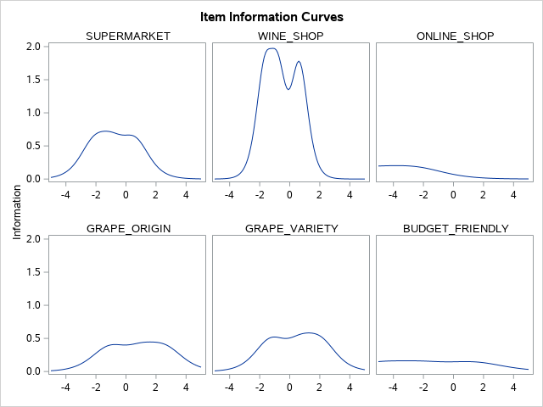

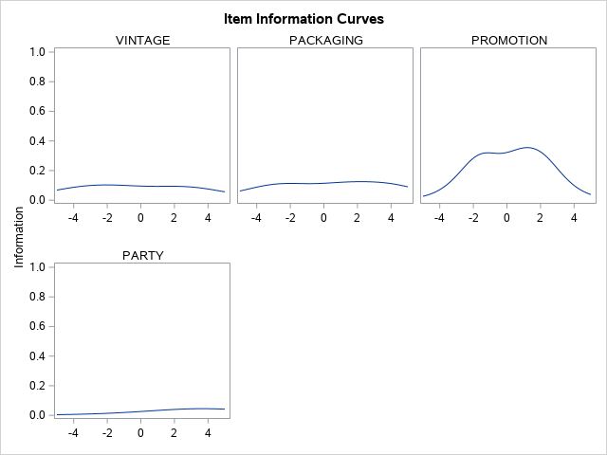

All the variables apport some amount of information, hence we will not remove any of these variables in order to avoid altering the information retrieved. As we can see all the variables are more informative for those subjects whose latent trait is close to the difficulty level.

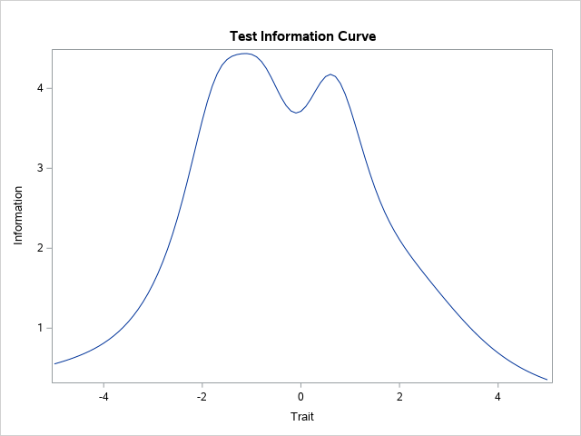

As we can see the test information curve covers amost all the rage, but for a further improvement it would be necessary to add items that are more focused on lower and higher levels of the latent trait.

#### **4.5.2.4 Factor2**

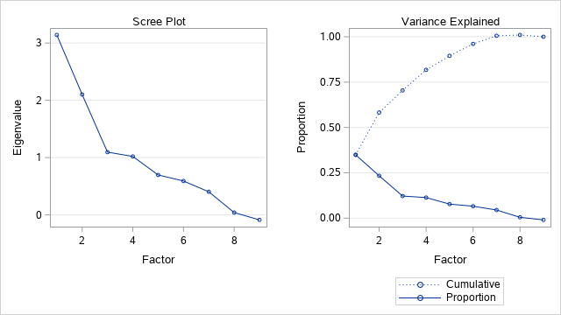

Also for this factor we can see that our division was done in a good way. Let’s analize the parameters.

| **Item Parameter Estimates** | | | | | | |
| --- | --- | --- | --- | --- | --- | --- |
| **Response Model** | **Item** | **Label** | **Parameter** | **Estimate** | **Standard Error** | **Pr > |t|** |
| **Graded** | **BUYING_EXPERIENCE** | BUYING_EXPERIENCE | **Threshold 1** | 1.38265 | 0.41955 | 0.0005 |
|  |  |  | **Threshold 2** | 3.96634 | 1.11609 | 0.0002 |
|  |  |  | **Threshold 3** | 5.06617 | 1.47721 | 0.0003 |
|  |  |  | **Threshold 4** | 7.14848 | 2.18966 | 0.0005 |
|  |  |  | **Threshold 5** | 7.44861 | 2.29751 | 0.0006 |
|  |  |  | **Slope** | 0.51884 | 0.16079 | 0.0006 |
|  | **WINE_BOTTLES** | WINE_BOTTLES | **Threshold 1** | 0.88064 | 0.11649 | <.0001 |
|  |  |  | **Threshold 2** | 0.54729 | 0.10406 | <.0001 |
|  |  |  | **Threshold 3** | -0.69326 | 0.10511 | <.0001 |
|  |  |  | **Threshold 4** | -1.24484 | 0.14694 | <.0001 |
|  |  |  | **Threshold 5** | -1.59823 | 0.18404 | <.0001 |
|  |  |  | **Threshold 6** | -2.02689 | 0.24445 | <.0001 |
|  |  |  | **Slope** | -3.23203 | 0.91690 | 0.0002 |
|  | **BRAND_AWARNESS** | BRAND_AWARNESS | **Threshold 1** | -4.21083 | 1.05919 | <.0001 |
|  |  |  | **Threshold 2** | -1.88446 | 0.51458 | 0.0001 |
|  |  |  | **Threshold 3** | 2.79868 | 0.68830 | <.0001 |
|  |  |  | **Slope** | 0.59565 | 0.15298 | <.0001 |
|  | **LABEL_INFO** | LABEL_INFO | **Threshold 1** | -3.92681 | 1.02279 | <.0001 |
|  |  |  | **Threshold 2** | -1.12249 | 0.39968 | 0.0025 |
|  |  |  | **Threshold 3** | 3.04957 | 0.77003 | <.0001 |
|  |  |  | **Slope** | 0.51629 | 0.13411 | <.0001 |
|  | **BOTTLE_BUDGET** | BOTTLE_BUDGET | **Threshold 1** | -1.34814 | 0.30616 | <.0001 |
|  |  |  | **Threshold 2** | -2.61482 | 0.57769 | <.0001 |
|  |  |  | **Threshold 3** | -4.03485 | 0.94400 | <.0001 |
|  |  |  | **Slope** | -0.93456 | 0.23870 | <.0001 |
|  | **BUYING_FREQUENCY** | BUYING_FREQUENCY | **Threshold 1** | 5.33197 | 1.77751 | 0.0014 |
|  |  |  | **Threshold 2** | 4.16205 | 1.37116 | 0.0012 |
|  |  |  | **Threshold 3** | -2.74390 | 0.96450 | 0.0022 |
|  |  |  | **Threshold 4** | -6.88780 | 2.33534 | 0.0016 |
|  |  |  | **Slope** | -0.41941 | 0.14258 | 0.0016 |
| **TwoP** | **GIFT** |  | **Difficulty** | -1.27692 | 0.27669 | <.0001 |
|  |  |  | **Slope** | -1.01409 | 0.24822 | <.0001 |
|  | **HOME** |  | **Difficulty** | 0.23666 | 0.09806 | 0.0079 |
|  |  |  | **Slope** | -3.01036 | 0.82623 | 0.0001 |
|  | **TASTE** |  | **Difficulty** | -2.49542 | 0.63700 | <.0001 |
|  |  |  | **Slope** | -1.07953 | 0.35476 | 0.0012 |

Also in this case all the items’ difficulties seems to be balanced, the only two items that can be considered relatively difficult are “BUYING_EXPERIENCE” and “BUYING_FREQUENCY”.

Let’s analyze how the items contribute in providing information.

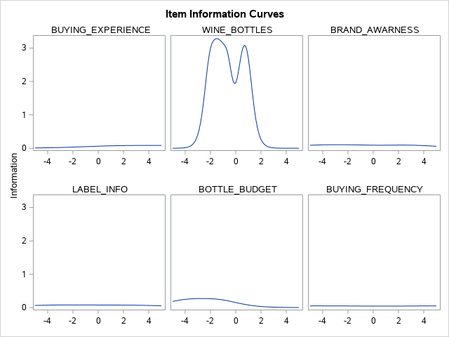

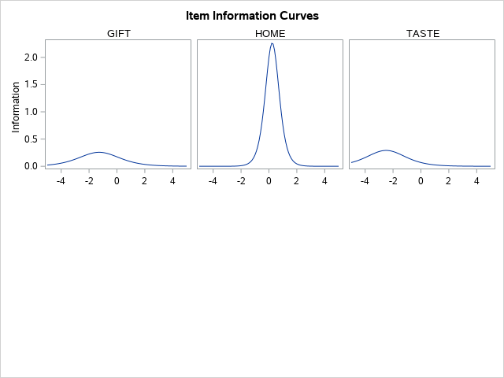

We can notice that also in this case we don’t have any item that is able to be informative for those subjects with a very high or very low latent trait.

As we can see there are four items that provides little to none information at all. The only item that provides no information at all is “BUYING_FREQUENCY” let’s see if it is safe to remove them

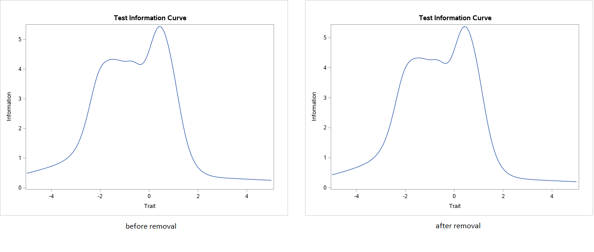

As we can see the Test information curve remains the same and so it is safe to remove the item.

Also in this case the test is not accurate for subjects with an higher level of the latent trait.

#### **4.5.2.3 Etna DOC Wine**

The items in this topic are:

* ETNA_DOC
* ETNA_BUYING
* ETNA_PREFERENCE
* ETNA_FLAVOR
* SICILIAN_EXCELLENCES
* ETNA_EXPENSIVE
* ETNA_QUALITY
* ETNA_RECOMMENDATION

Here the IRT model will be applied to all these items except for ETNA_DOC, considering that it was the discrimantory question to finish the questionnaire, in fact if we try running PROC IRT including also ETNA_DOC it will skip the calculation of the Pearson chi-square model and interrupt the computation.

Let’s start looking at the scree plot



As we can see in this case we, thankfully, have that one single latent trait drives the responses.

As usual, now we will have a look at the estimated parameters.

| **Item Parameter Estimates** | | | | | |
| --- | --- | --- | --- | --- | --- |
| **Item** | **Label** | **Parameter** | **Estimate** | **Standard Error** | **Pr > |t|** |
| **ETNA_BUYING** | ETNA_BUYING | **Threshold 1** | -2.65466 | 0.50939 | <.0001 |
|  |  | **Threshold 2** | 0.50623 | 0.18294 | 0.0028 |
|  |  | **Slope** | 0.90241 | 0.17655 | <.0001 |
| **ETNA_PREFERENCE** | ETNA_PREFERENCE | **Threshold 1** | -2.28931 | 0.25441 | <.0001 |
|  |  | **Threshold 2** | -0.80289 | 0.12466 | <.0001 |
|  |  | **Threshold 3** | 2.07287 | 0.23130 | <.0001 |
|  |  | **Slope** | 2.15628 | 0.30981 | <.0001 |
| **ETNA_FLAVOR** | ETNA_FLAVOR | **Threshold 1** | -2.26216 | 0.23019 | <.0001 |
|  |  | **Threshold 2** | -1.03141 | 0.12388 | <.0001 |
|  |  | **Threshold 3** | 1.12235 | 0.12917 | <.0001 |
|  |  | **Slope** | 3.20976 | 0.52298 | <.0001 |
| **SICILIAN_EXCELLENCES** | SICILIAN_EXCELLENCES | **Threshold 1** | -2.56419 | 0.33633 | <.0001 |
|  |  | **Threshold 2** | -1.74905 | 0.23848 | <.0001 |
|  |  | **Threshold 3** | 1.31425 | 0.19186 | <.0001 |
|  |  | **Slope** | 1.47788 | 0.21703 | <.0001 |
| **ETNA_EXPENSIVE** | ETNA_EXPENSIVE | **Threshold 1** | -2.90022 | 0.56172 | <.0001 |
|  |  | **Threshold 2** | 2.17310 | 0.42664 | <.0001 |
|  |  | **Threshold 3** | 4.45044 | 0.88620 | <.0001 |
|  |  | **Slope** | 0.87614 | 0.17924 | <.0001 |
| **ETNA_QUALITY** | ETNA_QUALITY | **Threshold 1** | -2.44641 | 0.25699 | <.0001 |
|  |  | **Threshold 2** | -1.07092 | 0.12956 | <.0001 |
|  |  | **Threshold 3** | 0.99348 | 0.12632 | <.0001 |
|  |  | **Slope** | 2.77894 | 0.41064 | <.0001 |
| **ETNA_RECOMMENDATION** | ETNA_RECOMMENDATION | **Threshold 1** | -2.64018 | 0.28968 | <.0001 |
|  |  | **Threshold 2** | -1.81608 | 0.18965 | <.0001 |
|  |  | **Threshold 3** | -0.67946 | 0.10659 | <.0001 |
|  |  | **Slope** | 2.92060 | 0.50387 | <.0001 |

As can be seen from the table, there are no extremely easi nor extremely difficoult items.

Let’s see how much information each item provides.





Even though also here not the full spectrum for the latent trate is covered, this items are better distributed than the others covering a good part of the spectrum. All of them provide information so there is no way to remove items without losing information about the subjects.

Let’s see how the test information curve behaves.



Differently from the other topics here less information are provided for subjects with a latent trait level close to the difficulty level of the items, instead more information are given for those with a lower latent trait level.

#### **4.5.3 IRT on factors**

# Conclusion

# Appendix: questionnaire improvement